Should we turn a blind eye to AIDS victims?

Introduction
Nowadays, there are many facilities and funding to help the increasing number of AIDS victims. However, the public assert that the AIDS victims do not deserve any help from others. This project is going to explain this phenomenon, give some common misconceptions and suggest ways to foster empathy as suggested by Mr. Samual Yu, the chairman of the Advisory Management Committee of the Red Ribbon Centre in his interview.


Current issues
In Hong Kong, at the end of December, 2006, the accumulated total of reported HIV and AIDS cases were 3198 and 855 respectively. Newly reported HIV cases in 2006 was 373, which is a 19% increase when comparing with that in 2005. 70% of the infected persons were Chinese and 80% were men.

Sexual transmission is the most common mode of contracting HIV, accounting for 75% of all infections.

Existing facilities and funding given by Hong Kong government

The Department of Health (DH) is the lead Government agency for implementing a multi-pronged approach in the prevention and control of HIV/AIDS.
In order to start the approach, DH’s Centre for Health Protection has set up a Special Preventive Programme (SPP) to work to achieve the purposes. SPP’s main working areas are surveillance—SPP monitors the local HIV/AIDS situation through voluntary reporting system, studies among high-risk groups and behavioral data collected through DH’s service outlets such as AIDS Counseling Service.
The second working area is the prevention and health promotion. SPP conducts programmes through Red Ribbon Centre which engages community participation in AIDS education and prevention. It develops AIDS education programmes and facilitates local and international collaboration in the fight against HIV/ AIDS.
The last working area is the diagnosis, clinical treatment and care. SPP provides clinical services to AIDS patients and people who are HIV positive to facilitate early diagnosis, diseases treatment and control, reducing the risk of transmission.

In addition, DH also provides support to the Advisory Council on AIDS which advises the Government on policies relating to the dealings with AIDS and the Council for the AIDS Trust Fund which considers applications for grants for programmes and projects on HIV/AIDS publicity and public education.

Comments on government’s work
As commented by Mr. Yu, the Hong Kong Government has played a very active role in helping AIDS victims and HIV carriers. The Government has spent one hundred thousand on medical services per year and 0.3 billion has been used on education and health promotion since 1993. AIDS victims who are permanent residents of Hong Kong can enjoy free medical services. These figures prove that Hong Kong Government has tried their best in helping AIDS victims and HIV carriers. Since when comparing with some other economically more developed countries like Europe and the US, the funding given by Hong Kong Government is nearly as much as those countries.
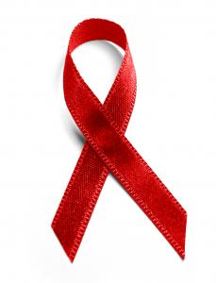
In addition, in the early 1990s, there was a group of patients with haemophilia, who contracted AIDS through blood transfusion. The government took the immediate responsibility by compensating the patients and improving the system of testing whether the blood contains HIV virus. This shows that Hong Kong government is very responsible and cares wholeheartedly for the AIDS patients.

People’s opposition towards the facilities and misconceptions on AIDS
The Red Ribbon Centre has been working continuously to find out the misunderstandings of citizens towards AIDS victims so as to carry out workable measures to help them. After their research, Mr. Yu concluded that people think that the AIDS victims do not deserve so much help from the Hong Kong Government and other organizations as they are infected due to drug abuse or unprotected sex which are immoral activities. Thus, they must be responsible for their condition.
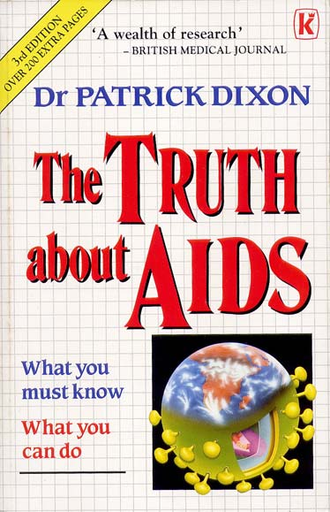
Citizens in Hong Kong commonly have some misconceptions towards AIDS victims and HIV carriers. They think that AIDS is a fatal disease and cannot be cured. The victims are usually sex workers, homosexuals or drug abusers and cases are mostly related to unprotected sex. In addition, they believe that AIDS can be transmitted through social contacts like talking to each other and having meals together. According to the survey carried out by the Centre for Epidemiology and Biostatistics of the School of Public Health, The Chinese University of Hong Kong in 2005, 42% of respondents refused to have any social contacts with AIDS victims and 43% of respondents thought AIDS victims deserve no help from others since they carried out immoral activities. Therefore, citizens think that victims are not worth so much empathy.

True picture of AIDS
In order to convince citizens that they should show empathy towards the victims and support the policies implemented by different organizations, they should first be taught correct concepts about AIDS.
Although AIDS cannot be cured, there are medicines and Cocktail Therapy that can suppress the virus inside bodies and thus the physical situation of the victims is just the same as ordinary people. They are not as terrible as what people think.
Secondly, victims may not get virus solely because of unprotected sex. There are other ways like blood transmission and parental transmission. They may not get the virus actively, but through transmission.
Thirdly, AIDS cannot be transmitted via social contacts, but only by exchange of two liters of saliva or blood, etc. Therefore, it is absolutely safe to be friends with AIDS victims.

Things different parties can do to foster empathy ( government, organizations, schools)
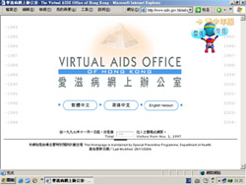
In order to alleviate the problem, the Hong Kong Government helps the AIDS patients in various aspects. Medically, AIDS curing methods such as Cocktail therapy is being used to increase the life expectancy of AIDS victims. Socially, the government helps them to integrate into the society by promotion of social acceptance especially for children who contracted the AIDS virus from their mother. Assistance and counceling services are given to help them overcome obstacles when facing other people as well as their future lives. AIDS Trust Fund is also an essential element other than medical and psychological care.

On the other hand, Red Ribbon Centre mainly uses promotion and education as a medium to foster empathy. In 1997, Special Preventive Programme launched a website, named "Virtual AIDS Office", to communicate with health professionals and the community through the internet. Sharing sessions by the AIDS patients are being organized regularly. Mini poster and pamphlet on HIV/AIDS treatment, prevention of blood-borne infections, safer sex etc are given to the public. Also, a telephone hotline “Dr Sex Hotline” set up in July 1996 by the Department of Health and Hong Kong Sex Education Association has a 24-hour pre-recorded message in Cantonese, Putonghua and English. It provides information on AIDS related problems. It also helps assist teachers and youth workers while carrying out sex education programmes.
With promotion and education, more empathic attitude could be enhanced; these would also strengthen the linkage between government and the society.
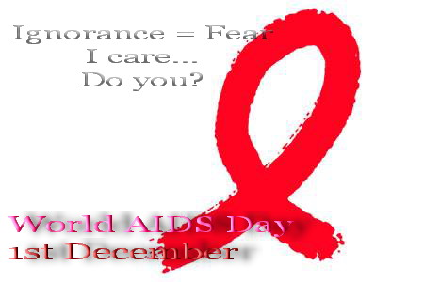
Furthermore, students could try their best to promote the idea of not discriminating against the AIDS victims in their daily practice so as to protect themselves while fostering empathy, such as not discriminating against them by having lunch with them. They should also try to help them when they have enquiries in doing homework and during lessons. These are some of the effective ways as these can give an impression to those AIDS victims that they are the same compared with other normal students. On the other hand, as the adage goes “Fear always springs from ignorance”, if students try to enrich their AIDS knowledge and promote the right perception to classmates and the others, they will not be afraid of having social contacts with the AIDS victims as they will not be infected with AIDS when having social contacts.

Future Expectation
The Red Ribbon Centre expects the government to provide adequate and effective medical care to all AIDS victims in Hong Kong. With medical improvements, AIDS is a chronic but not a fatal disease. Now, it can be controlled and it has no immediate threat to life, so helping the AIDS victims return to ordinary life is more important as they still have years to live. Hence, people in society should not discriminate against them, should not avoid direct social contacts, develop closer relationships, and show care and concern to them. These measures would be extremely helpful to the AIDS patients.
Furthermore, nationally, the government could try to maintain a low infection rate by setting up legislation and stop the coming of mainland sex workers to Hong Kong. Sex education is also essential for younger generation by teaching them the correct attitude towards sex so as to achieve the ultimate target of reducing the infection rate.
However, this is a great challenge as there are still homosexual sex workers between Hong Kong and the Mainland and this cannot easily be monitored. As it is a cross broader issue, both Hong Kong and Mainland government should cooperate well.


Conclusion
From the analysis above, we found that there is an increasing infection of AIDS and the reason behind public ignorance is the misconceptions. Therefore, every citizen in Hong Kong should do their part to alleviate the problem. A harmonious society can be built in the future only if all citizens take an active role to accept and care for the AIDS victims around them. With care and concern on part of each citizen, a more tolerant and harmonious society can be envisaged in the near future.

