Report on “Body image”

Introduction
Marcia Hutchinson, author of the book Transforming Body Image, states, "Our body image is formed out of every experience we have ever had - parents, role models, and peers who give us an idea of what it is like to love and value a body. Image is formed from the positive and the negative feedback from people whose opinions matter to us. It is also the way we ourselves have perceived our body to fit or not fit the cultural image."
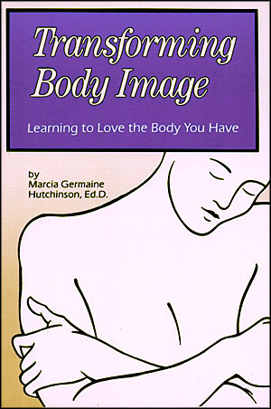
A research done by the Hong Kong University reflects that on average, an adult female spends 31 years on slimming while an adult male spends 28 year. The result is surprisingly high and far from expectation. Weight has become the criterion in judging whether someone is pretty or not. Thin, therefore, has become the beauty standard. This report is about the current craze among the ladies struggling for a slim figure because of the massive promotion of the idea “Thin is In” by the mass media. The aim of this report is to show how the slimming craze is affecting Hong Kong women and how the mass media are spreading the idea of “ Thin is In”.

Current Situation

Body image
- A survey of 1446 of men and women revealed that nearly two thirds of them are unhappy with their body and feel that being thinner would make them happy Especially women, who equate being slim to attractiveness
- As a direct consequence of the slimming craze, 72% of Hong Kong women are underweight. Most of them are turning to slimming as the way to improve their appearance
- 86% of Hong Kong office ladies are in pursuit of achieving desired body weight by enrolling in all sorts of “slimming treatments” or searching for weight loss shortcut without the need of dieting or exercising
- Women take slimming drugs in order to keep slim, aiming to make themselves look more beautiful
Media
One of the major factors leading to this trend is the influence of the mass media. The Hong Kong media has been portraying a distorted view of beauty---the magazine covers are full of skinny models and the slimming companies always bombard us with stories of how they transforms a fat and unhappy woman into a charming beauty. Slimness equated to Feminine beauty has become the standard and the female populace has started finding ways to lose weight.

Before: After:


Findings
We interviewed a weight-loss company, Sau San Tong Healthy Trim Institute. The company claimed that weight-loss companies did not exert pressure on fat people. They denied having promoted feminine beauty in their advertisements. In addition, the company denouncced being part of the trend “Thin is In” . They claimed that the goal of this slimming company was to help people lose weight in a healthy way and their targets were those in need. Also, they provided fully trained consultants and up-to-date nutritional information. They aimed to create a healthy and friendly positive atmosphere.
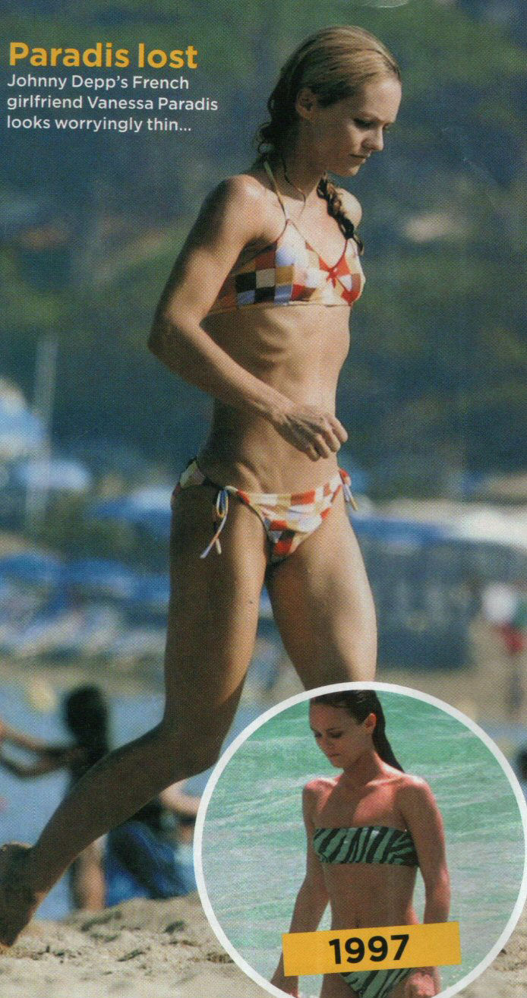

Impact

Body image
Symptoms of poor-diet are:
- Miscarriage:
Women who have a low body mass index before they become pregnant are 72% more likely to suffer a miscarriage in the first three months of pregnancy
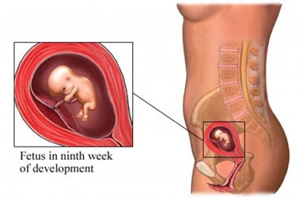
- High blood pressure
- Schizophrenia
- Osteoporosis
- Sudden death
- Slimming drugs may result in high blood pressure, and abnormal metabolism or stimulate the central nervous system and increased metabolic rate

Media

The media have given young women the impression that only thin girls deserve to have a wonderful life and are worthy of those they love. Influenced by the media, more women are trying to keep fit and lose weight.
There was a survey conducted by a cosmetics company DOVE in 2004, based on interviews with 900 teenage girls aged 15 to 17 from Taiwan, Korea, Singapore and other Asian countries. The findings have shown that local youngsters are influenced by the media and tend to view how they look as the key to confidence and happiness. It also mentioned that while most students know advertisements are an exaggerated version of reality, they cannot help but feel threatened by the attractive people around them.
Recommendation
Body image
Tips to keep slim body figure in a healthy way,
- Walk more and taking the stairs instead of using elevators all add up
- Take a walk after meals or go shopping
- Take a 10 minutes break during work to do stretches or light weight training
- Ask doctors to check if you meet the normal body weight. Normal body weight varies among different individuals, and is influenced by a complex of different factors, such as height and age. There are various ways to find out whether an individual has a normal body weight, and below are some examples:
Method 1: Body mass index (BMI)
- Body mass index is a convenient method of assessing body weight. The World Health Organization has devised a system of calculating BMI using body height and weight.
- Calculation: Weight (kilogram me) / Height (meter) ²
- The World Health Organization suggested in 2000 that the desirable BMI range for Asian adults should be 18.5 to 22.9.
Method 2: Waist-hip ratio
- The waist-hip ratio is a measurement of central obesity, which is the quantity of fat accumulated around the waist.
- The waist-hip ratio is related to the risks of cardiovascular diseases. A high ratio suggests that most of the body fat is accumulated around the waist, which means there is an increased risk of cardiovascular diseases.
- Calculation: Waist Circumference (cm) / Hip Circumference (cm)
- Various types of research show that the desirable waist-hip ratio should be less than 1.0 for men, while the desirable waist-hip ratio should be less than 0.85 for women.
- Consume 2 to 4 servings of fruit a day instead of slimming drugs
- Take supplements or fresh fruit and vegetables which can reduce the risk of miscarriage
Recommendation
Media
The media should try to change their culture and show the correct image of feminine beauty.
- On the silver screen

Filmmaking and adverting industries can cooperate and bring the message that beauty comes in every body size, so as to encourage the audience to consider inner beauty more rather than the outward appearance. For example, this message was showed in a movie in 2001- Shallow Hal.

The story is like that:
Hal is a shallow man who used to look at women's physical beauty only. One day, he is hypnotized by a stranger and becomes able to see others' inner beauty. He falls in love with Rosemary, a warm-hearted and funny woman.
In everyone's eyes, Rosemary is a heavily obese woman. However, in Hal’s, the kind-hearted woman is stunningly beautiful. At the end of the story, Hal wakes up from his hypnotized state and comes to realize that Rosemary is actually morbidly obese. He is shocked by Rosemary's physique, but he still loves her despite her weight.
While a lot of movies and advertisements put people's successes down to their good looks and skinny shapes, Shallow Hal gives us an opportunity to examine our own concept of beauty

Apparently, more movies or advertisements can be produced in a similar way; we think this is one of the effective long term measures to change people’s perception and educate our next generation by giving them a correct value on beauty.

- On roadside billboards
There is a modeling company called “PlusModels”. All the models they use are plus-sized company and their slogan is “because beauty doesn’t only come in a size “six”. Despite this, their models still can have a great success--Barbara Brickner is one of the examples. She is arguably one of the most famous plus-size models in the world. With countless campaigns, magazine covers and even a calendar to her credit, the model with the famous smile has a career that shows no sign of slowing.
This shows us that not only the slim models can be successful in the modeling industries; plus-sized models can behe same too.

As a result, if more companies are willing to use more plus-sized models instead of accepting slim models only, there will be fewer women attempting to reduce their weight in order to enter the modeling industries.

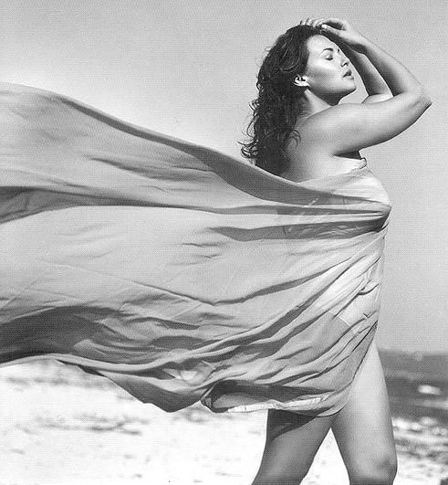

- On Catwalk
The fashion industries should reduce or even ban the use of models that are underweight and suffering from anorexia For example, the organizers of the Madrid fashion week, which took place last September, decided to turn away any model that had a Body Mass Index (BMI) lower than 18. This can establish a healthy image on modeling and relieve the pressure on overweight people in society.

Conclusion
The increasing number cases about being weight in Hong Kong prove to us that over-slimming is a pressing issue. In terms of education, the government can organize campaigns to spread the message of the importance of a healthy diet. Famous stars can be invited to be the spokespersons of the campaigns. They can be starred in the advertisements, in order to exert more positive influence on the public. Besides, the media needs to take responsibility and try to show a healthy and realistic image of feminine beauty. With the government and the media working hand in hand, we believe that this problem can be alleviated more efficiently, and a healthy population can be eventually achieved.

