The Tragedy of Cinderella

Introduction
In Disney’s fairy tale “The Story of Cinderella”, Cinderella and the prince live happily ever after. In reality, when the Hong Kong Government met the Walt Disney Company, the fantastic dream vanished. The Company failed to protect Hong Kong from the economic downturn. Hong Kong Disneyland was opened on 12 September 2005. Hong Kong was soaked in an atmosphere of jubilance after the Hong Kong government successfully signed contract documents with Walt Disney Company. However, series of scandals and problems have popped up since the construction of the theme park, and these have badly affected the park’s image.
This report aims to compare the benefits and drawbacks of Disneyland to Hong Kong, and to assess the influence of Disneyland on Hong Kong in different aspects. Lastly, it suggests ways how the Disneyland Company can improve the present situation.

Current Situation
Hong Kong Disneyland operates by a joint-venture company of the Hong Kong Government and The Walt Disney Company. The park cost $5.7 billion, of which the Government injected $3.25 billion and Disney Company inject $2.45 billion. The graph below shows Hong Kong government injected more money on the park then the Disney Company.

The park is located on 125 hectares of reclaimed land with many attractions, including Adventureland, Tomororrowland, Fantasyland, Main Street in U.S.A., fireworks displays, Sleeping Beauty Castle, Mad Hatter Tea Cups and a few others. The major difference between Hong Kong Disneyland and other Disneylands is having a stunning mountain and sea view. In 2008, “it’s a small world”, a boat ride attraction, Animation Academy for visitors to learn how to draw their favourite Disney characters, Mickey’s WaterWorks, a water-based day parade will be added to the Disneyland.
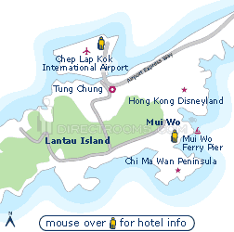

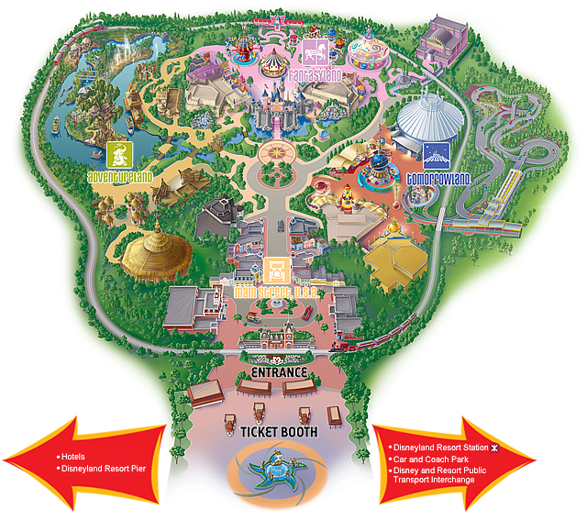

The following graph shows the composition of visitors in Disneyland. Mainland visitors are the major tourists in the park. It shows that the park mainly attracts Mainland tourists and the high - end foreign tourists are less attracted by Hong Kong Disneyland.
At, the same time, Disneyland faced many difficulties and problems even before the grand opening. They are pollution during construction work and firework displays, impoliteness of the Disneyland staff and unhygienic conditions in restaurants.
All the above statistics show that Hong Kong Disneyland cannot boost Hong Kong’s tourism industry.

Findings
Hong Kong Disneyland is assumed to bring benefits to Hong Kong in the future. It is expected to attract millions of tourists a year, create thousands of jobs, enrich the quality of life, and enhance Hong Kong's international image. The Hong Kong Disneyland is proposed to provide Hong Kong with a net economic benefit of up to $148 billion over 40 years. However, unfortunately, problems have come before benefits. In order to have a deeper understanding of the problems of Hong Kong Disneyland, we have interviewed Ms. Lee of the Disney Hunter to comment on the recent operation of the Hong Kong Disneyland.
To start with, Ms. Lee claimed that the Hong Kong Disneyland failed to show high standard of cooperation with its major investor, the Hong Kong government. It did not allow the inspectors of the Food and Environment Department to go into the park to investigate the food poisoning case. The park staff forced them to remove their caps before entering the park. This scandal brought forward the fact that the Hong Kong Disneyland is having too much power, and is supposedly expedited from Hong Kong’s score of legislation.
Secondly, Hong Kong Disneyland has failed to bring long-term economic benefits to Hong Kong. It was estimated that Hong Kong Disneyland would attract 3.4 million incoming tourists in the opening year. However, it failed to meet the target. Furthermore, Hong Kong Disneyland is only a stepping-stone for the Disney Company to extend its market to mainland as mentioned by Ms. Lee. A park in Hong Kong may help the company to establish its business in China. She worried that if the Disney Company built another larger scale Disneyland in Mainland, Hong Kong Disneyland will fail to compete with it. Since no matter how many times the Hong Kong Disneyland carried out large-scale reclamation to expand, its size must be still smaller than park in Mainland. Hong Kong Disneyland would therefore fail to compete with the Mainland Disneyland and to boost Hong Kong tourism in the future.
Other than the above, Ms. Lee also claimed that the Hong Kong Disneyland would fail to achieve sustainable development. During the construction and expansion processes, large-scale deforestation and reclamation have harmed the sea creatures. Also, Disneyland’s fireworks every night, further worsens Hong Kong’s poor air quality and is environmentally unfriendly. And the Disney Company is not eager to use environmental friendly fireworks as it will increase its operation cost. Furthermore, the reclamation and dredging of Penny’s Bay to accommodate Disney has destroyed the coastline, coral reefs and a fish spawning grounds. According to the Hong Kong newspaper, the Standard, since late 2000, after Disneyland’s reclamation work began, fish farmers near to Penny’s Bay have reported the deaths of over 500000 kilograms of adult fish and about three million juveniles from 260 species were killed. Disney Company’s environmentally unfriendly and short - sighted policy has made Hong Kong suffer.
Also, around forty-five stray dogs were used as unofficial guard dogs on the Disneyland construction site. Hong Kong government noticed the case and sent dogcatchers to catch those dogs. However, before the arrival of dogcatchers, the stray dogs were being injected with poisons and killed by Disneyland staff. This alarmed the Society for the Prevention of Cruelty of Animals and showed the disgraceful attitude of Disney Company on those stray dogs.
Some may argue that the park did provide economic benefit e.g. 18000 job opportunities to Hong Kong. However, it seems that Hong Kong had to suffer greatly before receiving any benefits. At this stage, the park fails to give a boost to Hong Kong’s tourism industry and brings more drawbacks than benefits.

Suggestion
Hong Kong Disneyland should divert its targeted tourists from Mainland Chinese to high-end foreigners by launching more advertisements overseas. So the Hong Kong Disneyland can be better known among the world. As a new Disneyland will be built in mainland in the future, Hong Kong Disneyland cannot rely greatly on Mainland Chinese. It should expand its range all over the world.
In reply to the environmental issue, Hong Kong Disneyland can follow the measures in United States California Disneyland to use environmental friendly firework. For example, it can use compressed air instead of gunpowder to lift fireworks so as to reduce emission of ground level smoke. Also, it is suggested that the length of time for the firework displays be shortened to reduce the amount of pollutants released. By the way, the Hong Kong Disneyland should carry out environmental impact assessment before any construction work in the future, to minimize the negative impact on the environment. During reclamation, nets can be put into the sea to block the flow of mud water and stone so as to prevent the contaminated water from destroying the habitat of sea creatures. Furthermore, it should finish the reclamation as soon as possible to reduce the duration for water pollution.
To increase the competitiveness of Hong Kong Disneyland, the Disney Company should develop more new attractions that cannot be found in other Disneylands. Some people, who have already visited other Disneylands, believe that Hong Kong Disneyland is similar to the others, and the size of Hong Kong Disneyland is the smallest among the other Disneylands. The attractiveness of Hong Kong Disneyland decreases. So, Hong Kong Disneyland can increase the number of visitors by developing more attractions.
Lastly, the Walt Disney Company must discipline itself and change its lax attitude towards the government. The Hong Kong government should have stricter control on the park. Like other government-owned company, if there are problems about the Disneyland, it should be discussed in the Legislative Council.

Conclusion
Hong Kong Disneyland is a dreamland for many youngsters. Unfortunately, it seems that Cinderella met the wrong prince, so the prince cannot wake her up and it fails to improve its tourism industry effectively and Hong Kong people’s dream cannot be realized since it started with a series of problems. With a shaky base, it is quite difficult to attract more guests to come if existing problems remained. These prove Disneyland to be a white elephant at this moment. As a result, it is very important for the Hong Kong Disneyland to improve its cooperation with the government and the public. And, raise its competitiveness in the future in order to survive in Hong Kong.

Reference

LEAD: Hong Kong Disneyland officially opens
http://findarticles.com/p/articles/mi_m0WDP/is_2005_Sept_12/ai_n15403189
RTHK
http://www.rthk.org.hk/special/hkdisney/

Disney Hunter
http://disneygp.no-ip.org/
Hong Kong Disneyland
www.hongkongdisneyland.com

Special thanks to Ms Lee of Disney Hunter
How come it is $US, not $HK?

