Report on Hong Kong’s Environment

Introduction
Our investigation intended to find out Hong Kong government’s seriousness in cleaning up Hong Kong’s environment. At present, Hong Kong is facing different kinds of environmental problems such as air pollution, water pollution and land pollution. For air pollution, the emission of global gases, such as nitrogen oxide and carbon dioxide, has an increasing trend since 2000 (see fig 1). This report outlines the government’s attitude and effort in
tackling the issue.
Fig 1 Hong Kong Total greenhouse gases emissions

Ms. Karen Hung, an expert on land pollution, of the Green Student Council was interviewed. She shed light on local green groups’ effort in dealing with land pollution in Hong Kong. The report further details the efficiency and effectiveness of environmental policies carried out by the Hong Kong government and suggests ways to improve the current situation.

Current Situation
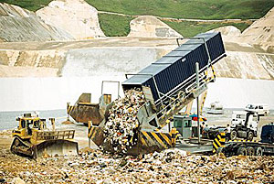
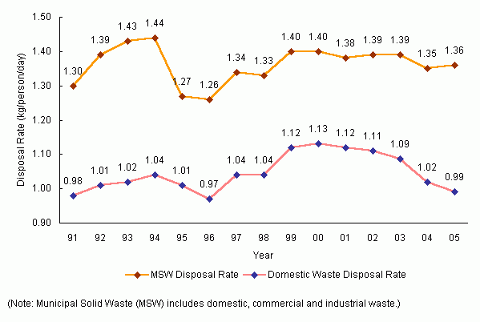
The municipal waste-loads of Hong Kong have increased on an average of about three percent per year since 1986. (Refer to figure 2) Together with the increasing population, per capita level of domestic waste has risen from 0.95 kilogram per person per day in 1990, to 1.11 kilogram in 2002. The continuous growth in waste-loads means that Hong Kong is running out of landfill space much earlier than expected. The remaining landfill space will last for 6 to 10 years only if the situation continues.
Fig.2 Per Capita Disposal Rates of Municipal Solid Waste and Domestic Waste in 1991-2005 (data from EPD)
Besides, according to data from the Hong Kong Environmental Protection Department (fig 3 & fig4), deposal waste form domestic and public cleaning and construction has occupied the largest percentage of quantities of major types of solid waste disposed, which are 39% and 37% respectively.

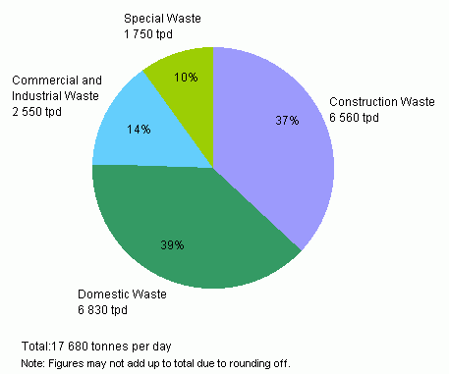
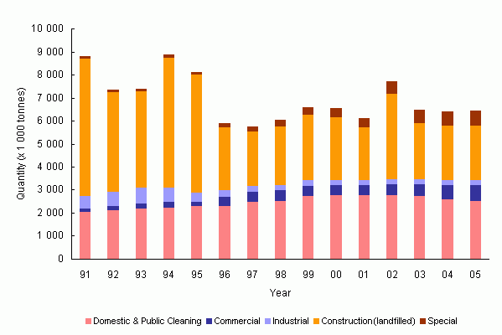
Fig. 4 Quantities of Major Types of Solid Waste Disposed of in 1991-2005
Fig.3 Types of Solid Waste Disposed of at Landfills in 2005 (data from EPD)

Findings
A. Series of policies made by the Hong Kong government
Name: | Municipal Solid Waste (MSW) (A trial scheme) | Name: | No Plastic Bag Day (supported by the government financially)
Duration: | Three months | Duration: | The first Tuesday of each month
Content: | Residents will use designated bags for disposing non-recyclable domestic waste and will use “food waste bags” to separate domestic waste from food waste | Content: | Consumers are encouraged to bring their own shopping bags or to donate $0.5 for each plastic bag they ask for on that day
Comments: | The wastes collected in the programme were sent to landfills also.  The process before seemed to be meaningless and this trial program seemed not well-planned. | Comments: | Encouraged citizens to bring their own bags and reduce the number of plastic bags. It also increased the awareness of using less plastic bag as to protect the environment.  The idea of No Plastic Bag Day should be expanded so that the number of plastic bags disposed in landfills can be further reduced.
Name: | A fixed penalty of $1500 for Littering
Duration: | Started from 24th June 2003
Content: | Anyone who commits such offers as littering, spitting, unauthorized display of bills and posters, or fouling of streets by dog faeces in public places in Hong Kong shall be liable to a fixed penalty of HK$1,500.  Seven departments of Hong Kong Special Administrative Region government are responsible for enforcing this fixed penalty system.
Comments: | 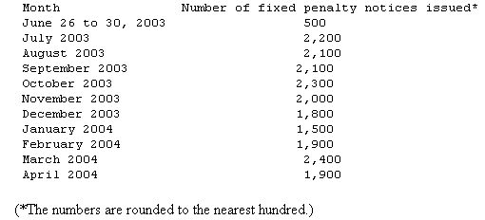  Fig. 5 Number of fixed penalty notices issued from late June 2003 to end April 2004  Since this policy started in practice, an average of 2000 fixed penalty notices is given to citizens each month. (Refer to figure 5) In certain extent, this policy is effective in deterrent citizens not to throw rubbish on the streets. However, as we can see, the amount of rubbish on streets was still in a great number, it is also found that citizens would repeat in committing the policy again and again, representing the enforcement of this fixed penalty was not enough. It is also found that some citizens are uncooperative with the enforcement officers. Hence, the government may employ more enforcement officers to enhance the effectiveness of this policy.

B. Cooperation between internal departments of the Environmental Protection Department
(ie. policy making department, education department and a department for facilities)
Even though policies are made and facilities are developed, without education, desirable results cannot be achieved. Education should be used as a means to arouse citizens’ awareness of environmental protection. Without knowing the reason for protecting the environment, citizens would not have the initiative to cooperate with government’s policies.

C. Successful measures carried out by the overseas governments

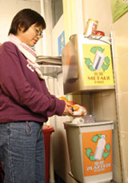
(i) Taiwan
Taiwan has made use of kitchen wastes in compost or changed them into organic soil to be resold later. It is believed that similar measures will be suitable in Hong Kong. The Taipei government requires all households to separate different types of wastes into different plastic bags every day. Using economic incentive by which those who produce more waste have to buy larger plastic bag of higher price, encourages citizens to produce less waste.
(ii) Singapore
In Singapore, the disposed waste goes into incineration plants or landfills. Since April 2001, the Singapore government has a progamme in place called the “National Recycling Programme” to provide residents in HDB flats and landed estates with recycling services. Within a short period, the participation rate of households in recycling has reached 22 percent. And the waste disposed off in Singapore has decreased from a peak of 7,600 tons per day in 2000 to 7,000 tons per day in 2006. The recycling rate reached a new high of 51% in 2006, up from 40% in 2000.

Recommendations
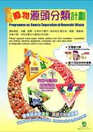
A. Better education
Education is a long term solution to help clean up Hong Kong. Education teaches the public and the younger generation about the appropriate attitude in consuming resources and changes their perceptions. The government can also promote the needs and advantages in keeping Hong Kong clean by telling citizens the consequences if they do not change their habits.

B. Better cooperation between government departments
At present, the government departments divide their work clearly and independently and so they do not know each other’s works well. With better cooperation between government departments, they can be more effective and efficient in carrying out policies or organizing campaigns.

C. Better cooperation between the government and green groups
The government and green groups can share their points of view towards policies and include different opinions. Hence, the policies can become more comprehensive and fulfill the human-oriented principle.
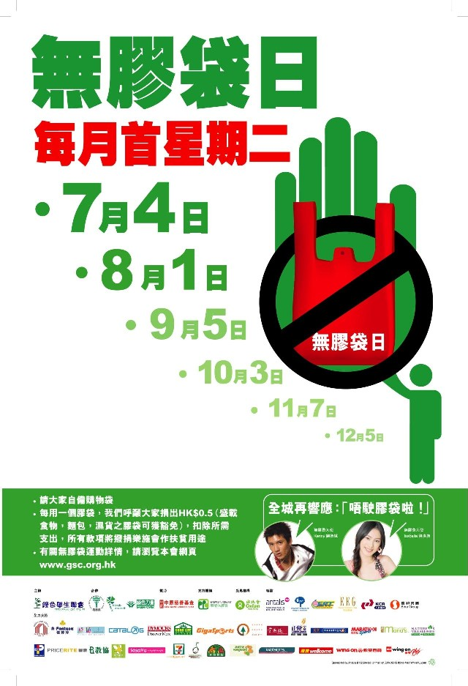
Besides, they can organize activities or campaigns together to achieve the purpose of raising the awareness of the public in cleaning Hong Kong. For example, “No Plastic Bag Day” is one of the effective campaigns. Therefore, it is recommended that the government carries on the task of the green group and holds this campaign. The government can increase the number of days of “No Plastic Bag Day “gradually to let the citizens adapt to the life without the use of plastic bags.

D. Legislation
By legislation, the situation can be improved in the short term. If citizens would be penalized if they do not obey the law, they will change their behaviours immediately as to avoid being punished. Therefore, it is effective to lessen the impact of pollution on the environment in the short term.
Apart from that, it is easier for the government to carry out more strategies related to environmental protection with legislation. It is necessary for the citizens to contribute their supports and efforts as it is impossible to protect the environment just with the policies carried out by the government.

Conclusion
It is found that the Hong Kong government is actually passive and conservative in carrying measures to solve the problem of land pollution in Hong Kong.
Firstly, the government is not active in promoting the idea of environmental protection among citizens. Advertisements are not frequent and these often lead to failure of campaigns.
Secondly, the government is hesitant to have measures that have great influence on the current situation because of the pressure that it may be blamed or criticized by citizens. Thus, they are not willing to take the lead and make great changes.
Undoubtedly, the Hong Kong government is willing to make Hong Kong a better place to live in and is willing to clean it up, but the policies or campaigns they are not as effective as expected due to problems in cooperation between internal departments of the Environmental Protection Department, for example, the trial Municipal Solid Waste program
However, the government can take the successful measures which are carried out by other countries as a reference. And it is expected that they can improve the situation and alleviate the problems by putting more efforts and resources in carrying out measures and promoting the proper attitude about treating waste among the public.

Reference
-South China Morning Post |  | -Websites
-The Standard |  | -News.gov.hk
-Environmental Protection Department |  | -TIME
-Ministry of the Environment and Water Resources, Singapore |  | -Food and Environmental Hygiene Department

<THE END>

