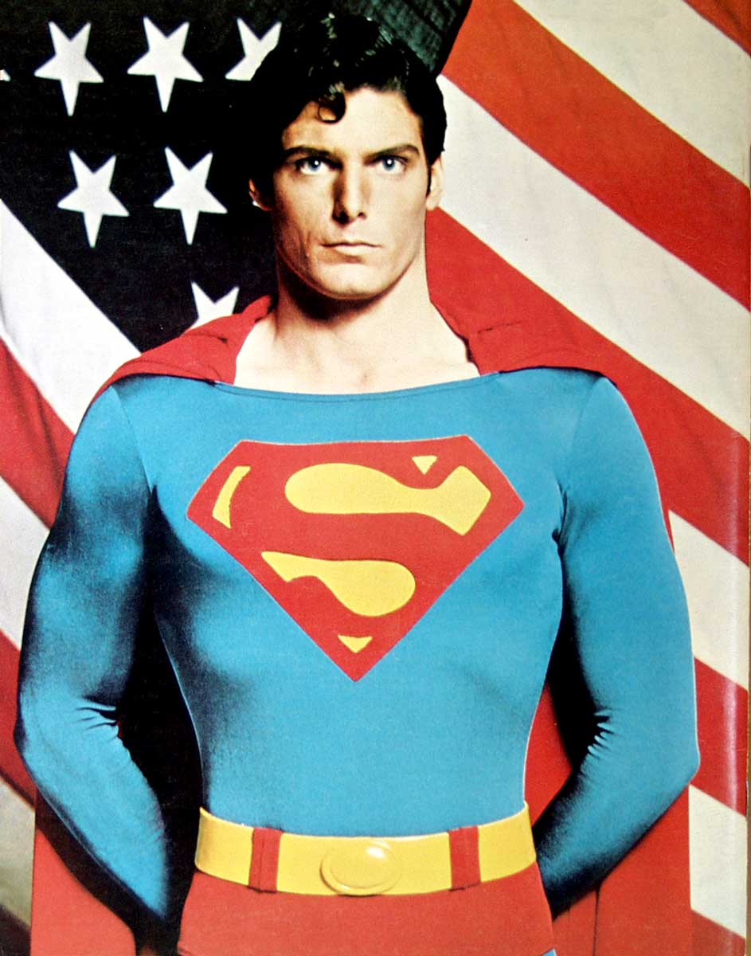
My favourite historical figure – Christopher Reeve
Everyone has an idol. My idol is Superman, Christopher Reeve. He was born on 25th September, 1952 in New York City and died on 10th October, 2004.

He was quite interested and talented in music and piano when he was very little. He was picked to be in an operetta for Princeton’s professional theatre. He received his B.A. from Cornell University and he later attended the Juilliard School in New York City.

In 1979, Chris was picked out of 200 hopefuls for the role of Superman because of his good look and talent in acting. In 1979, he won the British Academy Award for Best Actor for his excellent performance in Superman.

Besides his performing career, he was also very successful in many other aspects. He shown profound interest in various sports which made him an expert. He was also an expert sailor, skier and horse-rider!

In 1995, Christopher Reeve attended a riding show, all of a sudden, his horse balked at a 3-foot-2-inch fence and made an adrupt stop. He landed on his head and got a broken spinal cord! He has been paralyzed from the neck down ever since.

He was unable to breathe without a machine bumping his lungs. However, his family did not give up on him and gave him a lot of support.

He often got frustrated but he didn’t give up. He has given speeches around universities, urging medical graduates to find the cures for paralyzed patients.

He was given the National Courage Award at the Minnesota Courage Centre. He set up the Christopher Reeve Paralysis Foundation and the Reeve-Irvine Research Centre. He was the vice chairman of National Organization of Disability. He was also the chairman of American Association.

His acting life restarted in 1998. He published an autobiography called “Still Me”.

I think he was really a successful person! Although he had become disabled, he didn’t give up and even began his acting life again! For a person who used to be healthy and active, it must be very hard to find himself always sitting on a wheelchair, not able to move his muscles. However, he was determined to live a meaningful life. We can all give meaning to our life by learning from Christopher Reeve, his passion for life and his never-giving-up attitude.

By Connie Chan 2C

Comment:
The biography of Christopher Reeve is very inspiring, especially for teenagers nowadays, who tend to give up easily.

