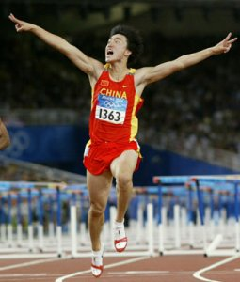
Profile of Liu Xiang –
The first Chinese gold medallist in the track and field events
Do you want to be the “only one”? “Only one” gives a special feeling to everyone. Today’s protagonist is the “only one” Chinese man who won the golden medal from the track and field in the Olympics history. Yes, he is Liu Xiang!

Liu Xiang was born in 1983 in ShangHai. When he was young, he practiced jumping in the Junior Sports School. But after a bone test showing that he will not be able to become a tall man, he was asked to give up. Although he can’t participate in jumping anymore, he was determined to compete in the Olympics in the future.

The year of 1998 was a turning point for Liu Xiang because he attracted the attention of a famous hurdle coach – Sun Haiping. In only three years’ time, Liu Xiang broke the world youth record and Asian record with the time of 13.12.

Allen Johnson was a great opponent of Liu Xiang. He broke the Asian record and won a lot of competitions. They have participated in the same competitions. Sometimes, Liu Xiang was the winner. Sometimes, Johnson was the winner. Liu Xiang did a better job of clearing the hurdles but Johnson’s stronger start ended up making the difference.

In 2004, Liu Xiang met Johnson in the Olympic Games which was held in Greece. They both put up an exciting show. Unfortunately, Johnson was crashed out of the games after falling at the ninth hurdle at round 2. Johnson’s early exit paved the way for Liu Xiang’s win. Liu Xiang finally entered the final turn of the male 110-metre hurdles. All the audience watched without blinking. When Liu Xiang dashed passed the finishing line, all the spectator hailed with delight. It is the first gold a Chinese athlete has ever won from the track and field in the Olympics history. The happiest news was he clocked a stunning 12.91 seconds to equal the world record set by Britain’s Collin Jackson in 1993. After the race, he said to the camera, “Who said Chinese can’t do it?” with confidence.

In the advertisement of PCCW, Liu Xiang said how much he paid, how much he gets. One would not succeed without putting effort in anything. Set a target for yourself, put effort in it and head for your goal. You can be the “only one”. The last sentence of the advertisement is “the only one you need to surpass is … YOURSELF!”

Rebecca Wan 2D
Very fluently written and an inspiring conclusion is drawn.

