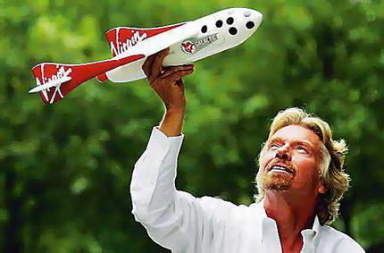
Profile of
Richard Branson –
The world’s famous businessman

Meet Sir Richard Branson. He is a famous businessman, also an adventurer. He likes excitement very much, so he has had a very interesting adventurous life so far. Here are some of the special thing he has done. If you are not so familiar with this man, read on!

Richard Branson was born in 1950. He grew up in a traditional family and received his education at Stowe School, where he established a national magazine entitled “Student” at the age of sixteen. Richard Branson started his first company when he was seventeen – a student Advisory Centre. Now he runs many different companies. They include airlines, music and soft drinks companies, all are named “Virgin”. Virgin Atlantic Airways, which was started in 1984, is now the second largest British long haul international airline and operates a fleet of Boeing 747 aircrafts to many international big cities. Also, this airline was found on the concept of offering competitive and high quality first class and economy service. It has earned “Airline of the Year Award” for many years. Richard Branson said years ago, “I want Virgin to be as well-known around the world as Coca-Cola. “Now he did it!

Sir Richard enjoys doing dangerous and exciting things. In 1986, his boat ‘Virgin Atlantic Challenger II” crossed the Atlantic Ocean in the fastest recorded time ever. One year later, his hot air balloon broke the world record by crossing the Atlantic Ocean. In 1991, he crossed the Pacific Ocean from Japan to Arctic Canada, again he broke the world record.

Apart from doing these kinds of activities, he also participated in TV programmes like “The Rebel Billionaire: Branson’s Quest for the Best” and “Global Business People”, etc.

Branson does not like smoking so he started a charity named “Parents Against Tobacco” aiming to limit tobacco advertisements and sponsorships in sports. He also donates a lot of money to other charities.

Sir Richard is one of the richest businessmen in the world but he still cares a lot about people. He writes his staff a letter every month and had a big party for them every year. They can write to him whenever they like and he always replies. He also invites some of his staff to his own island to spend holidays with him. He enjoys talking to them and listening to their ideas. “If my staff are happy, then my customers will be happy too,” He says.

I think there are few businessmen who have been as flamboyant and successful as Branson. I think one of the causes of his success is the way he treats his staff. He is friendly to his staff and treats them as his friends. He isn’t like other bosses who order his staff to work for him. As Branson has said, “Because the staff working in the company is happy and willing to contribute their best to the company, so the profit of the company increase year by year.” And I think this is a valuable lesson for us to learn.
By
Amy Tong
Comment:
That’s a special person you’ve chosen to write about! Through writing about Richard’s life, you’ve highlighted what kind of characteristics a successful businessman needs. Well-done!

