Regine Chan 6A (3)
Amy Leung 6A (16)
7. “Sport has a low profile in Hong Kong and will continue to do because of the lack of facilities and a lack of status.”
Is this statement true? Are there any other causes for Hong Kong’s poor reputation as a sporting power? Are there any plans to change this?

Introduction
The aim of this report is to find out whether the government has given enough support to sports or not and see whether sports have a high or low status in Hong Kong. A windsurfing athlete was interviewed to find out her views on this topic.

Current Studies
As Beijing will be the east holder of the 2008 Olympic Games, Hong Kong will also have the honor to hold the Equestrian Events. The 2008 Beijing Olympic and Paralympics Equestrian Events are going to be staged in Hong Kong. Also Hong Kong will host the East Asia Game in 2009. In order to have enough sport facilities to hold the events, the government has decided to rebuild the Hong Kong Sports Institute (HKSI) for the use of the Olympic Equestrian Events. The elite athletes need reside in the YMCA Wu Kwai Sha Youth Village (WKSYV). Many athletes oppose the decision of the government. Some elite athletes have even gone on strikes to protect their interests. Many of them think that the government does not care about them. But, in fact, the government has already put many efforts into sports (e.g. promoting sport to the public, holding some regional sport event etc.); Many elite athletes also get subsidies from different government departments. Also, the environment and the facilities in the temporary HKSI (WKSYV) are better than those in the old one.
Besides, many people complain that the government does not give enough effort in promoting sport in Hong Kong and does not provide enough sport facilities in local district. According to the interviewee (Cheung Yuen Yee), “There are not enough sports facilities in Hong Kong and most sports facilities are not up to standard. Also, Hong Kong lacks multi-purpose main games arena.”
In some districts, like Tung Chung, the residents do not have a swimming pool in their district. If they want to go swimming, they need to go to Tsing Yi. These cause a lot inconvenience to them.
Most sports do not have a high profile in Hong Kong. Many parents in Hong Kong didn’t want their children concentrate in school work only. So that why sport has a low profile in Hong Kong which are clearly illustrated in Exhibit 3 and Exhibit 21.. Sports are not popular amount Hongkonger.
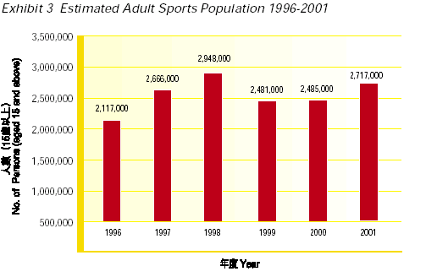

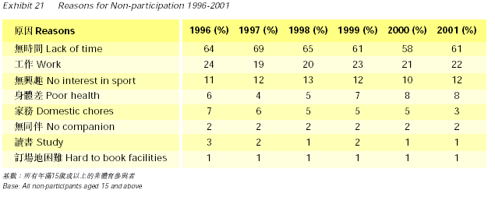

Findings
According to the recent news reports, the real situation is not as far as the elite athletes claim.
According to the Chief Executive's Policy Address 2006, the Government's investment in the sports sector is clearly a breakthrough for sport in Hong Kong. The Hong Kong Sports Institute (HKSI) is very optimistic that the additional Government funding will significantly improve and facilitate overall support for sport with coordinated facilities and planning. It will enable the HKSI to provide a better training environment for elite athletes, allow them to focus on training and further attract more young people to embark on the career path of an elite athlete.
The Chief Executive's announcement of earmarked funds for the redevelopment of the HKSI and the allocation of an additional HK$40 million in recurrent expenditure to provide comprehensive support for our elite athletes constitutes overwhelmingly positive news for the sports sector. The announcement further reinforces the commitment and support that the Government has rendered to sports development in Hong Kong until now.
- Redevelopment of HKSI
The HKSI was built 25 years ago and some of the facilities are now quite outdated. Following the temporary re-provisioning of the Hong Kong Sports Institute (HKSI) headquarters in the YMCA Wu Kwai Sha Youth Village on 1 January 2007, the main supporting facilities for elite athletes have begun operation.
The new Athlete’s Hostel comprises two, three-storey blocks, situated in a relaxing and pleasant environment. Trees surround the Hong Kong Sports Institutes (HKSI) Athletes’ Hostel, and the rooms are more spacious and equipped with sophisticated facilities for self-studying. With bigger rooms, compared with the previous hostel, the new Athlete’s Hostel can accommodate more than 100 athletes. Athletes believe their new hostel at the YMCA Wu Kai Sha Youth Village offers comfortable surroundings and sophisticated equipment, which will help in their pursuit of sporting glory.

HKSI vice-chairman, Tommy Tam Hok-lam said that the HKSI aims at providing a conducive environment in which sports talent can be identified, nurtured and developed to pursue excellence in the international sporting arena. Athletes are fully committed to both local and overseas training and competition. A tranquil atmosphere is vital for athletes to relax after undergoing intensive training. The extra build-in equipment and facilities in the Wu Kwai Sha Youth Village can definitely provide a better living environment to the elite athletes and enable them to concentrate on their training.
- Additional Government Funding
There are over 600 on scholarships athletes at the HKSI. They mainly come from 13 elite sports and two disability sports as well as other non-elite sports under the HKSI's Individual Athletes Support Scheme. The additional funding will undoubtedly reinforce the overall support for these elite athletes, which includes training and coaching expenses, sports science and medicine support, stipends, education, enhancement of social skills, career guidance and training and so forth. With these comprehensive support services, athletes can better equip themselves and focus on their training. Moreover, additional support can attract more young people to become elite athletes and strive for more honours for Hong Kong in upcoming Major Games, such as the 2008 Beijing Olympic Games and Paralympic Games, 2009 Hong Kong East Asian Games, 2010 Guangzhou Asian Games and the Far East and South Pacific Games for the Disabled. The HKSI will actively discuss and follow up with key stakeholders for the usage of the additional funding.
Moreover, in preparation of Hong Kong’s hosting of the 2009 East Asian Games and to raise local students’ awareness of our role as the host, the Federation has joined hands with the Leisure & Cultural Services Department to organize a School Sports Education Programme-Olympism and 2009 East Asian Games which will be held from 2005 to 2007 targeting all local Primary and Secondary Schools. Talks will be conducted in schools. The topics of the talks will include Olympism, Olympic Movement, 2009 Hong Kong East Asian Games and Hong Kong’s participation in Multi-Sports Games. Next, students will be invited to attend one of the sessions (12 sessions a year) held at the Sports House. Apart from talks conducted by qualified speakers, the programme also includes an elite athletes’ sharing session, which would allow students to meet their sports heroes face to face. This programme does not just enrich students’ general knowledge in sports but also helps to cultivate a sports culture among youngsters to prepare them for the 2009 Hong Kong East Asian Games as the host.
Also, the Athlete Incentive Award Scheme prize presentation, organized by the Hong Kong Sports Institute (HKSI), honors local athletes’ remarkable achievements. Athletes receive cash awards totaling HK$4,771,000. Athletes can fully utilize the resources that the Scholarships make available and unleash the enormous potential they have within themselves.
- “Sports for All”
Recently, the government is promoting the scheme of “Sports for All” (the information was given by the interviewee) in order to foster the status of sports in Hong Kong.
Conclusion
The HKSI believes that through the additional funding and the Government's commitment to the sports sector, the development of local sports will undoubtedly have a bright future. The HKSI will act in accordance with the Policy Address by cooperating closely with all related sports associations to promote the development of elite sports.
The status of sports in Hong Kong is rising, according to our interviewee (Cheung Yuen Yee). Because the Government has increased the budget and resources for sports and tried to promote “Sports for All”. And the government does have plans to improve the reputation of Hong Kong as a sporting power such as increasing the budget and resources for sports and promoting various programmes to promote sports.
Nonetheless the government should provide more training facilities to local athletes as Cheung Yuen Yee had said “The facilities are limited and athletes from different sports need to share the facilities. Also, Hong Kong Sports Institution (HKSI) is the only place in Hong Kong to supply all the facilities for athletes.” the government can do more to improve it.

