Teacher stress-a wake-up call for the EMB

Introduction
The issues of workload and work pressure of school teachers resonate in different regions all over the world. Hong Kong is no exception. As form 6 students, we discover that the problem of teacher stress exists in many schools including our school and this problem needs to be tackled without delay. The aim of this report is to study the stress of teachers and to examine what the government has done to tackle teacher stress. This report also recommends measures to reduce the pressure on teachers. Therefore, a selection of articles related to teacher stress has been gathered. Additionally, an interview with Mr Lee Yuk-fai, Steve Principal Assistant Secretary and Professor Edmond Ko, Chairman of the Committee, was conducted on 24th March 2007.

Current situation
Stress is a complex issue induced by various factors and agents. Recently, there is increased stress piled on teachers. In 2006, two teachers committed suicide because of the heavy workload and pressure. These cases of suicide were a wake-up call as there was nodoubt that work pressure was partly responsible for the suicide of teachers. Teacher stress does bring immense negative impacts. Principal Assistant Secretary, Mr. Steve Lee, mentioned that teacher stress is mainly attributable to heavy workload while it is due to two reasons. They are the increasing amount of administrative work because of education reforms and students’ behaviour.
Teachers in Hong Kong have been found to be disturbed by students’ emotional and behavioural problems. Mr. Lee said that changes in student profile presented fresh challenges. Emergence of single-parent or single-child family imposed a greater burden on teachers. Teachers often spend greater time and energy on students’ behavioural problems. Some teachers feel really depressed when they cannot manage to handle the students from diverse background and classroom discipline. According to Ms Chan, an English teacher, only recently recovered from the depression that drove her to contemplate suicide, "I felt so depressed at one point that I walked out of my classroom in the middle of a lesson and wanted to run up to the rooftop and jump to my death. One student was very naughty during that lesson and I felt very hopeless about my job and my life. My emotions were very unstable at that time.” A weak sense of satisfaction in teaching and a great degree of self-doubt increase teachers’ pressure.
Furthermore, according to Cheung Man-kwong, Professional Teachers’ Union President, teachers are forced to work longer hours than before to complete all the administrative work due to the education reforms. These have not only added to the burden of teachers’ workload, but also is the source of anxiety and frustration among teachers. Referring to reforms which brought about new tasks and challenges to teachers, the demands of multi-faceted skills in a fast-changing work environment confronted teachers with the added pressure of being adaptive. They need time to have trainings. In general, teachers have accepted heavier teaching loads because they enjoy teaching. However, they hate administrative work as they believe that such non-teaching work is not only unrelated to their role as teachers, but reduces the time they have for teaching. As shown in Table A, teachers devote around 15.8% of time on administrative duties like meetings and paperwork. Teachers ranked administrative duties as the least important, yet they took up the second largest portion of teachers’ time. Other than administrative work, teachers need to prepare their lesson and have continuing professional development and communications with parents. Teachers’ work is thus often extended to the weekends and holidays. A figure was estimated by the Committee on Teachers’ Work. Teachers usually worked 4.6 hours a day for non-school days and 10 hours a day on a school day, including the time spent working at home.
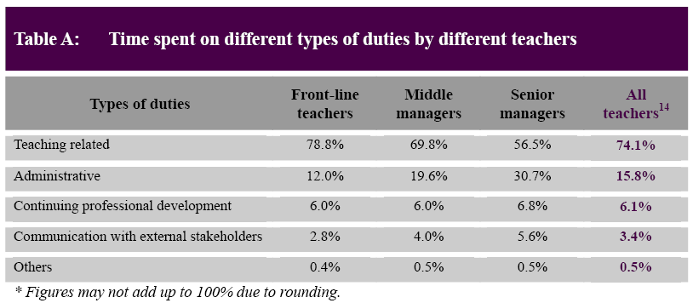

Solution
Because of the suicide of two teachers in 2006, the Education and Manpower Bureau has been forced to respond. The Committee on Teachers’ Work was formed in February 2006 by the government to look into teacher stress in Hong Kong. In fact, according to Professor Edmond Ko, Chairman of the Committee, undue stress on teacher will lead to decreased teacher productivity and wellness, teacher morale and job satisfaction. In serious cases, it will result in hypertension or burnout. With meetings with education groups, they have taken the following measures to tackle the problems:
- A new hotline for distressed teachers is set up so teachers will have the opportunity to share their difficulties with professionals, so it would be easier for them to figure out the solution.
- Extra $1.65 billion cash was given to schools to hire more administrators and top up their IT provisions for administrative purpose in hopes of making optimal use of what technology has to offer to improve efficiency and reduce the administrative burden of teachers.
- Concessions were offered on the September deadline for language teachers to meet benchmark requirements.
- The Education and Manpower Bureau has also lessened teachers ’ workload by simplifying the process of school-based assessments for Chinese and English, reviewing the arrangements for the territory-wide system assessment, further improving the arrangements for external school review and opening the Quality Education Fund to application.

Recommendation

Teaching Staff Establishment and Stability of the Workforce
With a view to cushioning the impact of school closures, it is high time the government maintained a balance between the overall supply and demand of teachers by introducing voluntary redundancies and reducing the student-to-teacher ratio.
In addition, in order to relieve teachers’ workload, we call on a small-class policy. Although this may not lead to better academic performance, it would surely reduce teachers’ stress and facilitate the volition in teaching practices that they are being asked to undertake.

Stress Management and Healthy Workforce
Teachers’ Education Institiute could consider placing greater emphasis on their teacher education programmes and on the physical and mental well being of teachers, alongside their professional growth. With stress and pressure being a part and parcel of contemporary life, teachers’ professional development could include components that address self management and personal growth, helping them to achieve better self understanding. They can also acquire and refine healthy life skills throughout their career, such as positive attitude, healthy coping techniques and time management.

Policy initiative
We reckon that communication within schools and among different stakeholders is crucial to quality education. In particular, there must be regular and open dialogue between the EMB and teachers to conceptualize and summarize teachers’ opinions in order to facilitate a better flow of information and feedback that will help clarify query or misconceptions, and on which a climate of trust can be built to facilitate long-term partnership. Communication should be two-way, requiring the conscientious efforts of the parties involved that are teachers, schools and EMB.
Furthermore, the EC could provide advice on gauging the capacity of teachers to cope and the impact of these initiatives on teachers’ work-life balance. Besides, it is essential for the bureau to strengthen counseling services for teachers

Teachers’ Continuing Professional Development
The EMB should explore various options to allow teachers the time and space to reap the full benefits of professional development activities, e.g. by providing paid study leave.

Conclusion
Teacher stress is a real phenomenon and is associated with quite a number of problems. Research has shown that teacher stress is mainly caused by increasing number of administrative work and students’ behaviour. As form 6 students, we should take ownership in learning and find ways to improve ourselves to let teachers feel satisfied as we ought to feel bound to alleviate the problem of teacher stress. It is hoped that the Education and Manpower Bureau would go to great lengths to prioritise the implementation plan and get the recommendation off the ground so as to allow teachers to do what they are best at and enhance students’ learning.

Reference:
- South China Morning Post
- Committee on Teachers’ Work
- The Standard – China’s Business Newspaper

