Bianca Yip (27), Emily Fok (6)

Research Topic 8:
“Co-education schools are better for both boys and girls.”
What are the advantages and disadvantages of co-educational as compared with those of the single sex schools? What are your conclusions?

Co-educational schools Vs single sex schools

Introduction

In Hong Kong, only 10 percent of schools are single-sex, however, girls’ schools seem to be achieving more than all boys schools. Studying in the co-educational schools, students appear to be more outgoing and develop a positive personality. But is this really the true picture? This report compares the advantages and disadvantages of co-educational schools with those of the single-sex schools and concludes which one of these is more preferable. In order to acquire persuasive and creditable findings, Mr Joseph Yuen, the principal of Cheung Chuk Shan College was interviewed to find out his views.

Gender differences:

Boys and girls are both biologically and physically different. According to a book “Why gender matters?” written by the National Association for the Single Sex Public Education, girls and boys are wired differently. Girls have a better ability to hear and are more sensitive to sounds, so they react worse when they are being shouted at. Further more, girls’ brain in adapting to languages is higher than boys’. And for boys, they often excel under stress whereas girls flounder. They are more aggressive and disruptive in behavior. Also, it is claimed that boy’s brain is constructed to be better in mathematics while girls are more empathetic. As there are differences in the brain and authority system of different genders, boys and girls behave differently and see the world in a different way.

Values and attitudes towards co-educational schools and single sex schools

Parents’ point of view:

According to Mr Yuen, majority of the top private schools are single sex schools, which has a longer history of development being run by the religious organization, they have a higher prestige. As a result, reputation was established long ago and these schools attract lots of better students through alumni affiliation, especially those families from a higher socio-economic background. So, most of the parents prefer sending their children to single sex schools as they believe that single sex schools have better academic achievements when comparing with the co-educational schools. Parents are likely to send their children to schools so as to keep them away from distraction during the period of their studies.

Society’s point of view:

Co-education is a kind of more modern and applicable way of teaching. It has the social benefit of providing an environment that is more reflective of the diversity in our society.

Other factors that affect the divergent performance of co-educational and single sex schools

Other than the gender stereotypes of boys and girls, there are also factors that affect the performance of students in the coeducational schools and single sex schools. According to Pat Langham, the President of the Girls’ Schools Association better performances in single sex schools are not mainly because of separating the genders in teaching but is due to selection of students and students’ different social backgrounds. Besides, the academic success depends more on the teaching methods like adopting small class teaching and a strong curricula. In addition, they have dedicated teachers and equitable teaching practices.

Advantages of co-educational schools
Coeducation is the most natural form of education and there are numerous advantages. First of all, coeducational schools are likely to improve the social and personal development of students. The students are often more self-confident, well-balanced and well equipped to make new friends than their counterparts in single sex schools. In coeducational schools, friendships are developed in a very natural way as there are various activities by clubs or societies in school through which boys and girls can have the opportunities to cooperate with each other. This friendly learning atmosphere encourages students to express their views openly. According to Mr Yuen, students can also learn to behave, communicate with proper etiquette, pay more attention to their self image, and to care more about the views of the opposite sex. They have good motivation to be good, more critical and have a higher emotional sensitivity.
From Figure 1 we can see that students studying in co-educational schools have a more balanced social network, that means they have about equal number of friends from both genders(40%) as opposed to students studying in single sex schools(19%).

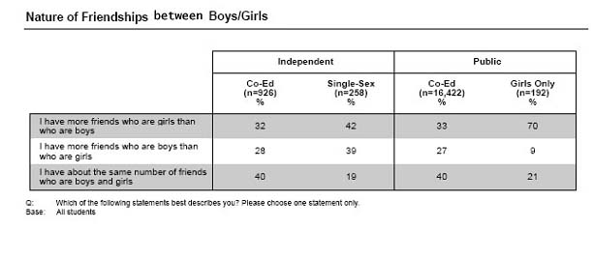
Figure 1

Secondly, coeducational schools provide both the boys and girls a large variety of subjects. Students have their freedom to choose the subject they are interested in. For example, girls may choose subjects like Technical Graphics and Materials Technology, which are seldom available in single sex schools for girls. By widening the range of subject selection, students can enhance their competence and confidence and also broaden their career opportunities in future.

Thirdly, it is a practice for students to cope with the opposite sex naturally since school is a natural imitation of the outside world. In coeducational schools, boys and girls can learn from each other and break down the misconception of the opposite sex. It can also provide an excellent foundation for students to develop relationships that are meaningful and long lasting in the future lives.

Last but not least, the whole families can attend the same school. According to many past students, coeducational schools enabled them to study with their family members in the same schools and they got to know them better outside home.

Disadvantages of co-educational schools
One big and critical problem is that sex harassment may occur in the coeducational schools. According to the research done by Professors Myra and David Sadker, who spent ten years studying sexism in classroom, almost 90% of girls in coeducation schools were affected by sex harassment in high school. This certainly makes the girls feel uneasy and leads to psychological problem.

Another point mentioned by Mr Yuen was that the curriculum planning need to cater for both sexes. Since the learning styles of boys and girls are different, pedagogy cannot favor both genders. For instance, girls are good at languages and boys good at Science and Mathematics. So, in that case, in co-educational school, remedial lessons are more commonly found to assist the weaker gender in class

Advantages of single sex schools
It was believed by most of the people that the academic results in single sex schools are mainly better than that of the coeducational schools. An Australian study of 270,000 students found that boys and girls performed 15 %and 22% better on the standardized tests when they were studying in single sex schools. Britain also carried out related research in 2001,which showed that the boys of the lowest ends academically improved the most in single sex schools and almost every female student studying in single sex school performed better than coeducation students. The study noted that the top twenty high schools are single sexes.

As there are gender differences, boys and girls should be separated in teaching. As mentioned above, boys are more assertive and disruptive; they are poor in language and better in mathematics. For girls, they are good at hearing and have a higher ability in languages. Since both genders are biologically different, pedagogy should be different for boys and girls. Hence, single sex schools can provide proper lessons to suit intrinsic characteristics.

In addition, according to Mr Yuen, girls’ schools prove to more advantageous in future career prospect. It is because better self-concept will be developed in a girl’s school rather than in a boys’ or co-educational schools. As girls tend to be more farsighted and concentrate on their studies more than boys, under the tense
competition, they excel their potential and achieve better.

Also, Single sex schools provide a more positive and nurturing learning environment. It is due to the freedom from pressure of the opposite sex. Students in single-sex schools have less worries about the view of others towards one self’s behavior, as a result, they makes fun and laugh and create a loving and more positive environment. Also, single-sex schools manage to draw up strategic plan to cater for the needs of the single gender.

Disadvantages of the single-sex school:

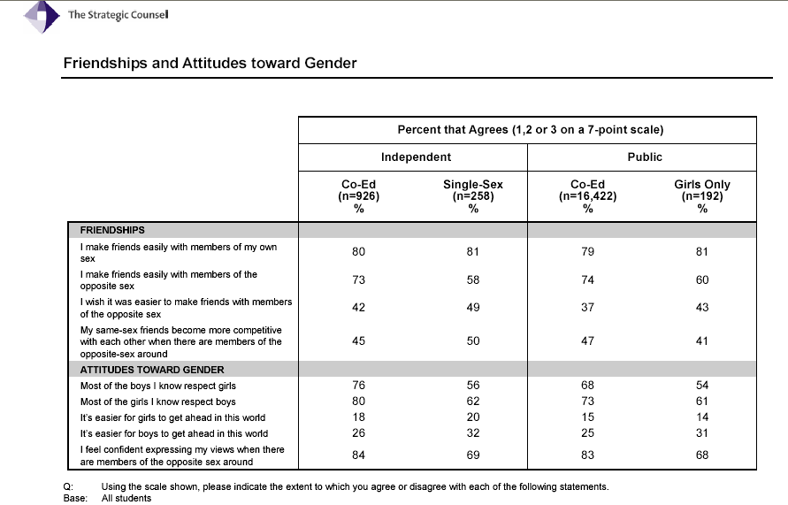 First, single sex school has a lack of opportunities for fraternization and socialization with the opposite sex. Students cannot learn social skills during their schooling. They tend to have a weaker human relationship handling skills with the opposite sexes compared to those studying in co-educational schools. As shown in the statistic below by the Statistic Counsel, the co-educational school students have greater confidence when expressing views to the opposite gender (84% agree) while for single sex school students, only 69% agree with this.

Second, according to the research done by the Strategic Council, students in the independent co-educational school have a higher level of interest in classes (83% agree) compared to the independent single sex school (76% agree)
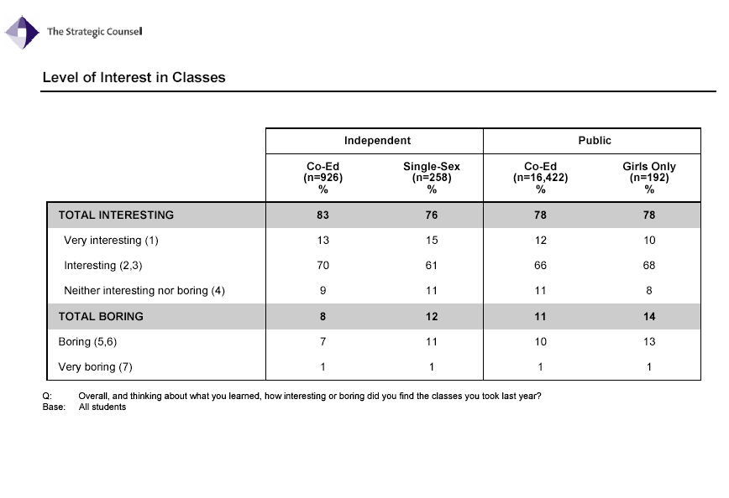
Third, co-educational students have a stronger academic interests and perception in ability. According to the statistic by the Strategic Counsel, generally speaking, co-educational school students have a quicker learning speed (90% for independent school) and 84% for single sex schools.

Conclusion
As a conclusion, based on the findings and comments from the expert, students in different schools do not develop definite and certain personalities. Instead it is the influence of cultural norm and the imposing of gender stereotype are the dominating factors. It is predicted that co-education will become a mainstream of education in the future of Hong Kong. Compared to single sex school, co-education shows its evident merits in preparing students for the outside world. Take for instance, it is most likely that university or the work place are the first places where pupils studying in single sex schools come with members of the opposite gender. We know that, during the stage of adolescence, it is the critical period that children have their specific stereotype and personal development. So, it will be late to incorporate them into mixed gender environment after their schooling. And co-education tends to be a more inclusive and comprehensive way of education, which provides more opportunities for boys and girls to cooperate and collaborate. It actually facilitates a microcosm of the real world where valuable social skills can be taught. And in co-educational schools, boys and girls can learn to respect one another's strengths and abilities. Thus, it is be more applicable and practical to the future society.

Acknowledgement
We would like to thank our English teacher, Mrs Prasad for her kind assistance and support for our project. Special acknowledgement is fowarded to Mr Joseph Lam, Principal of the Cheung Chuk Shan College for his precious time, effort and expertise.

Bibliography:

http://education.guardian.co.uk/schools/story/0,,1805641,00.html
http://www.bromleybrook.com/advantages.html
http://www.acer.edu.au/news/mr_pages/MR_singlesexschools.html
http://www.appleby.on.ca/apps/news/news/2006_Sept22_Coed.aspx
http://www.stjohns-chs.org/news/news_releases/coeducation.html
http://www.edweek.org/ew/vol-17/27aauhw.h17
http://www.dooyoo.co.uk/discussion/single-vs-mixed-sex-schools/1045187/
www.appleby.on.ca
http://findarticles.com/p/articles/mi_qn4158/is_20060627/ai_n16502854
http://www.capetimes.co.za/index.php?fSectionId=272&fArticleId=3317773
http://www.observer.guardian.co.uk/uk_news/story/0,,1805456,00.html
http://www.sdnp.org.gy/minedu/i-gender.htm
http://www.stansteadcollege.com/sc/archives/sc07/Co-Ed_FINAL.pdf

