
Surprise birthday!

Piles of presents,
Millions of greetings,
Thousands of cards,
Are many people’s desired birthday.

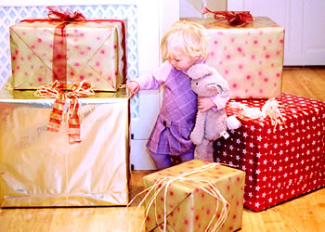
Dining with dearest family members,
Shopping with companions,
Enjoying chocolate birthday cake,
Is my desired birthday.

But on my 15th birthday on 15th of May,
I felt depressed,
I felt upset,
I felt lonely,
Because no one seemed to have remembered.

Sitting alone, watching TV alone,
Walking alone, playing alone,
I did everything alone.

Suddenly lights went out,
Candles glowed,
Homework removed,
Birthday cake placed.
Three people walked in
with lovely presents of My Dream,

They were mum, dad and sister,
They all shouted in an amazing manner,
Saying Happy Birthday, Bianca!

Bianca Yip

