World
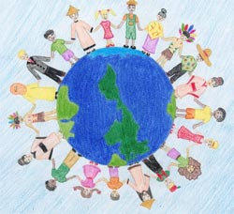
A thousand years ago
It was a beautiful world,
Full of grand views,
Full of natural resources,
Full of love.

In the second millennium
It was a modern world
In lack of wonderful views,
In lack of natural resources,
And in lack of love.

A thousand years later
It will be a horrible world,
Without scenic views,
Without natural resources,
Without love.

Watch out!
Let us save our world now!

Anna Wong

