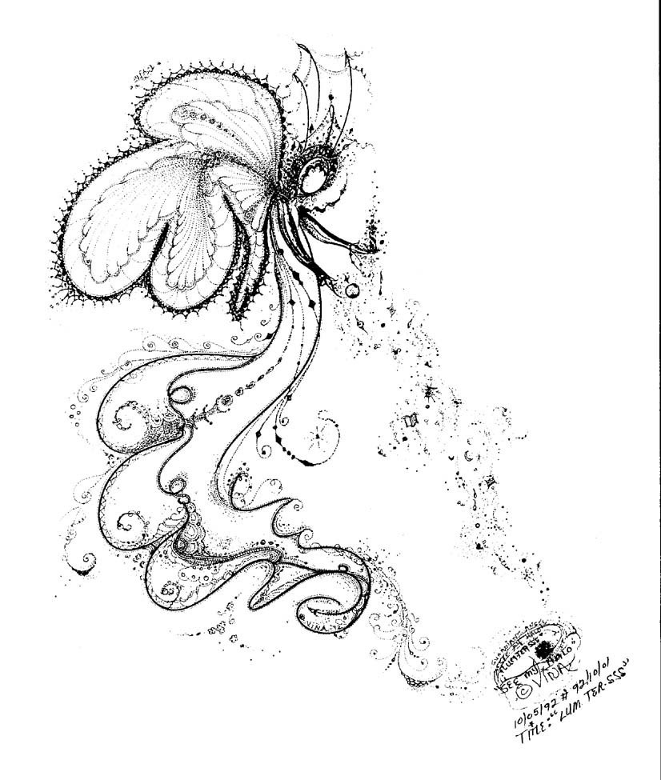
A Miracle

There was an old woman living in a small, wooden cottage alone. The old woman was a baker since she was small. She had wanted a son for a long time, and so, she prayed to god everyday, hoping that there would be a miracle. She was a nice person; she treated everyone in a good way, so everyone in the village called her “grandma”. Sometimes, she cried at being alone, and how she wished she had a son to be with. Most of the time, only her bread was her companion. So, she treated her bread as if they were her sons.
*
One day, the neighbors asked her, “Grandma, why do you often cry? Do you have a problem? If you really have something that bothers you, we will certainly help you.”

“I feel so sad because my bread was burnt. I have accidentally burnt one of them…I couldn’t believe I was so careless…” sobbed the old woman.

“You don’t have to cry. We can make as many loaves of bread as you want. We will help you,” the neighbors promised.

“Grandma, you are always so caring. You give me bread when I feel hungry. You never asked me to pay for that. I feel very grateful to you. Let me help you to make the bread!” a poor child said to grandma seriously.

And soon, everyone in the village was helping grandma. Some were helping to sieve the flour, some were rolling the dough, and others were watching the oven. “Boom!!!” Suddenly, there was a very bright lightning. And when all people reopened their eyes, they saw a pretty angel in front of them.

The angel was talking to grandma. “I know that you have a compassionate and thoughtful heart, and you always help those who are in need. Also, you are not a selfish woman at all, so my lord has decided to grant you your wish.”

Swiftly, the angel turned to the bread and pointed her magic wand on it, “Cling!” In front of all the people, they saw a French bread turn into a very human-like figure. At first, the old woman couldn’t believe her eyes. She cried and cried as she hugged the baby.

Later, she turned to the angel and thanked, “This is the greatest gift I’ve ever had. I don’t know how to thank you. You make me enormously ecstatic. I’m going to name my son “Angelo”. Thank you very much, angel!” Just when grandma wanted to curtsey, the angel disappeared.
As the days went by, Angelo grew into an incredibly intelligent and handsome, young man. He was very obedient and helped his mother a lot in baking.

Angelo later met a young girl named Edna, and fell in love with her. However, Edna was very selfish and even hated grandma. She thought that there’s no reason to be kind to anyone. But, she was a really good actress in front of Angelo. Edna pretended to be polite and well behaved when Angelo was around.
*
One day, Angelo went out for work. Only Edna and grandma were left at home. As soon as Angelo stepped out of the house, Edna began to show off her real attitude. She ordered grandma to vacuum the floors and serve her with luscious food. Unfortunately, Grandma was too old and she couldn’t hold the saucer tightly and dropped the food on the floor.

“You’re such a crazy woman! And you are so stupid! Do you see what have you done?” Edna scolded. She kicked grandma after that.

“Edna, I understand that you are still young and don’t know what is right and good for you. I’m not going to fight you back. Don’t worry…I’m not going to tell Angelo. But I’m sure that I can change you to a better girl,” Grandma continued, “It’s not important to get rewards from others, helping people is actually enjoyable. Besides, when we treat people well, we are also the ones who will be joyful…”

“Stop that! Old woman! You’re talking nonsense!” Edna interrupted.

However, grandma still continued talking about having a good attitude and tried to persuade Edna. As Edna felt thoroughly annoyed, she kicked grandma again.

“Stop that! Have you gone crazy? What are you doing to my mother? I have seen your real face now! You’d better get out of my house right now!!! I don’t know what I’m going to do to you!” Angelo reproached furiously.

“No, Angelo. Don’t do that. Do you remember you are sent by an angel? You should understand how to forgive others. I know that Edna was not in her right mind, and so, we should help to change her manners,” Grandma said.

As Edna heard all the words of grandma, she felt guilty and ran to her. Edna hugged grandma as she wept and asked for forgiveness. “Grandma, I’m really sorry for my bad behaviors. I swear that I shall be nice to everyone from today onwards.”

From then on, Edna became a very nice, elegant and tolerant lady. She also helped grandma in the bakery. Angelo later married Edna and they became a very cheerful family. As for grandma, she continued to help those people who were in need. Later, the people called her, “AN ANGEL IN DISGUISE”.

Cheryl Yeung

