Sara To (23) Kathryn Yung (30) F.6A
A Brand-New Fast Food Trend
Introduction
Fast food is very common in Hong Kong. We can find at least one fast-food restaurant nearby. McDonald, KFC, Burger King, Triple O’s, Café de Carol can be found everywhere in Hong Kong. Fast food means that the food can be prepared and served very quickly. It can save us time and is convenient.
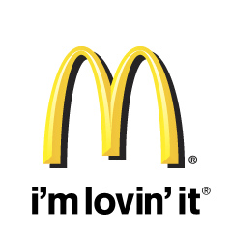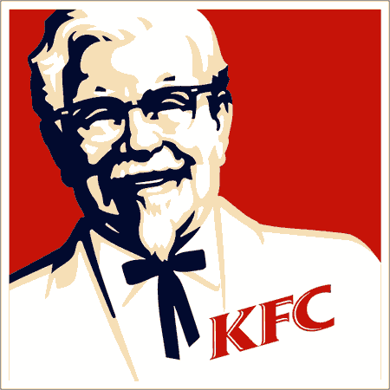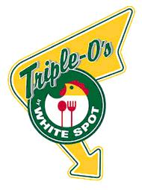

The aim of this report is to investigate fast food culture in Hong Kong nowadays. Firstly, trend of fast food culture in Hong Kong would be given in order to get further understanding of fast food. Secondly, negative impacts of fast food would be discussed. Thirdly, despite the fact that Hong Kong people are more aware of their health, fast food restaurants have emerged. Lastly, comparison between fast food shops and fast-service shops would be mentioned to find out how these two types of shops affect customers’ choice of catering.

Mr. Victor Chan, the Managing Director of the Triple O’s, Hong Kong franchise, was interviewed to find out the answer.

Current situation
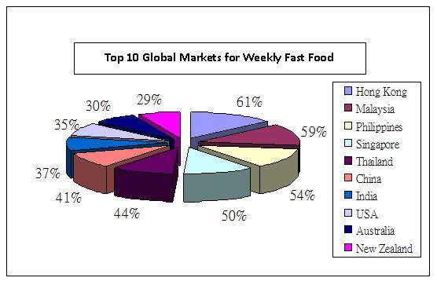Fig. 1 Top 10 Global Markets for weekly Fast Food
According to the survey from ACNielsen (Refer to figure1), Hong Kong has the highest percentage of eating fast food in the world, with 61 per cent of people eating fast food at least once a week. The survey was conducted in October 2004 over the internet in 28 countries and regions across the Asia-Pacific, Europe and the US. It showed that more and more people are obsessed with fast food.
Nine per cent of Hong Kong people visited fast-food restaurants at least once a day; 86 per cent of people visited at least twice a month. In the first nine months of this 2004, Hong Kong people visited fast-food restaurants on average seven times a month and spent $ 160. The survey revealed fast food has become a part of Hong Kong people’s lives.

Hong Kong people are in fast pace of life. People have less time to eat and are busy to work. It makes fast food become more and more popular because it is convenient and comfortable. It replaces the position of traditional restaurants and these fast food shops have dominated our society gradually.

Negative impacts of traditional fast food
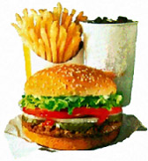
There are thousands of fast food shops in Hong Kong. They have totally changed eating habit and daily life of Hong Kong people. Albeit fast food is delicious and tasty, it brings several health problems. Fast food contains lots of fats and high calories. For example, McDonald’s provides a Big Mac, large fries and a large Coca-Cola drink which have 1430 calories. In fact, 2000 calories is the maximum amount a person needs in each day. Big Macs in Hong Kong contains more fat and cholesterol than those in the world. According to nutritional information on the company's website, each Hong Kong burger weighed 560 calories but 80 calories is more than Australia, 67 calories more than Britain and 60 calories more than the Middle East.

Obviously, fast food leads to obesity and diabetes, and increases the risk of heart disease and high blood pressure. Apparently, fast food contains high calories and lack in nutrition. Fast food is not proper meal that people can eat every day.

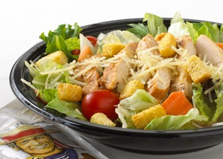
Besides this, facing the influence of mass media and the trend in Hong Kong, slim body figures are encouraged. Therefore, Hong Kong people realize the importance of health. They are willing to eat healthy food with low calories and fats. In order to meet the demand of healthy and higher nutritional food from Hong Kong people, fast food shops start to provide healthy food to customers. For example, McDonald’s try to give more choice to customers by providing healthier food, likes fresh salad and low fat yogurt. Fast food culture in Hong Kong has changed.

Emergence of Fast-service food shops in Hong Kong
Interview with Triple O’s – White Spot
Because of the rise in living standard and change in eating habits of Hong Kong customers, traditional fast food shops, such as McDonald’s and KFC, can no longer meet the demands of customers. The emergence of a brand new type of catering choice – fast-service food shops, introduces a new dining experience to Hong Kong customers, thus, bringing a positive and striking impact to the catering industry.

One of the most successful fast-service food shops in Hong Kong is Triple O’s – White Spot, which was founded in Vancouver, British Columbia in 1928, best known for its hamburgers In 2003, Triple O’s expanded its business to Hong Kong, setting up the first shop in the Great food hall in the basement of Pacific Place, Admiralty. Until 2010, there are already 5 Triple O’s established throughout Hong Kong, in which the franchises each record more than twice as many sales as the average location in BC. In order to know more about fast-service food shops, an interview has been conducted with the managing director of the Triple O’s, Hong Kong franchise, Mr. Victor Chan.

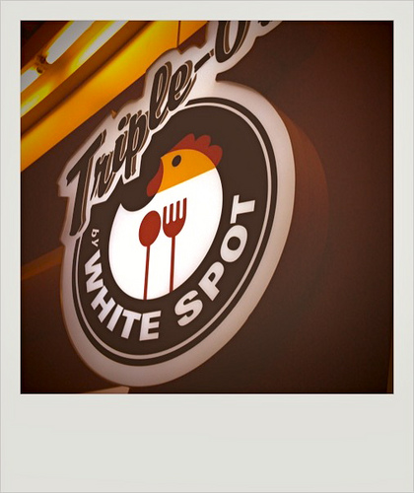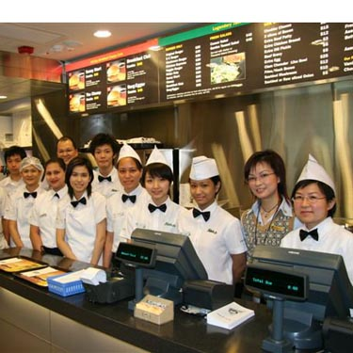

Triple O’s – White Spot aims to provide high quality, home-made and healthy fast food and family-friendly services to create a new kind of dining experience to customers. According to Mr. Chan, Triple O’s’ in Hong Kong have to follow strictly the menu and ingredients set by the Canadian headquarters to ensure its high food quality. For instance, unlike traditional fast food shops that only focus in lowering their production cost, Triple O’s’ milkshakes are made of fresh milk and premium ice-cream. Burger beef is from Australia, delivered fresh to Triple O’s in Hong Kong, not frozen. Mr. Chan added that Triple O’s’ menu will not change in order to suit the appetite of Hong Kong customers, therefore resulting in a limited choices of food in their menu compared to other fast food shops. In order to provide freshly made burgers, it usually takes up to 5 to complete a whole meal set. That is why customer-friendly service is provided in Triple O’s. Instead of ‘self-help’ service in traditional fast food shops, waiters will deliver meals to customers in person, offering customers efficient dining services. Besides that, because of the insistence of high quality ingredients, price of food is again higher than that of fast food shops. Yet, it does not affect customer’s choice of catering since they are now enjoying a higher living standard, willing to spend more for the return of good food and nice service.

Triple O’s’ success is also a result of change in eating habits and perceptions of Hong Kong customers. The idea of ‘thin is in’ is widely spread by the mass media, people are getting more conscious about their physique and health, leading to the rise of a new kind of eating habit – healthy eating. Believing that traditional fast food shops’ only provision of deep-fried food, customers tend to look for healthy, yet, delicious fast food for substitution. Triple O’s hit the exact demand of customers. ‘Food in Triple O’s is generally low in fat and that no preservatives and artificial flavours are added in. Vegetarian burgers and lots of vegetables are included in every meal set in order for customers to achieve a balance diet,’ said Mr. Chan, ‘healthy cooking methods are also used, such as roasting and grilling of burger beef and chicken stripes with refined olive oil rather than deep-frying. Fries with potato skins are again intended to provide dietary fibre for better digestion of customers.” Customers are free to choose according to their personal preference, having a custom-made burger in any way they want, like whether to add in any dressing in their burgers.

Another special feature of Triple O’s is that there is no advertisement about it at all. “We rather spend our money in purchasing high quality ingredients than wasting them on advertising. We believe that with our food and service, reputation can be build up in no time. Once again, we prove ourselves right!” said Mr. Chan. Marketing is clearly not the major concern of Triple O’s.

“From the fast food shops’ point of view, we (fast-service food shops) have become a huge competitor to the traditional fast-service shops. Like McDonald’s, they are, in fact, following our way in preparing food and provision of service. However, since there is vast difference between us and traditional fast food shops, we don’t treat them as a direct competitor. Our aim is not only to provide fast food to customers, but a new dining experience, which makes us unique in the catering industry.” Mr. Chan concluded by the end of the interview.

Comparison between Fast food shops and Fast-service food shops
Fast food shops have always been one of the dominating choices of catering. Yet, in recent years, there are a definite increasing number of fast-service food shops in Hong Kong, which result in an intense competition between the two. In the following table, we use the example of McDonald’s (fast food shops) and Triple O’s (fast-service food shops) to show the major differences between fast food shops and fast-service food shops, which affect customers’ choice of catering.
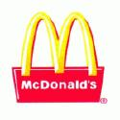
Differences | Fast food shops (McDonald’s) | Fast-service food shops (Triple O’s)
- Quality of food | Low | High
- Ingredients used | Use of low quality ingredients to cut off production cost e.g.  milkshakes – milk, water, and milk  powder  burger meat – organ meat mixed with  bread crumbs and onion | Strictly follow the Canadian headquarters’ use of high quality ingredients e.g.  milkshakes – fresh milk and premium  ice-cream  Burger meat – Australian imported,  pure beef
- Method of cooking | Deep-frying | Grilling and Roasting
- Health consciousness | Less  - lack of vegetables and fruits in the menu  - unhealthy cooking method used | More  - inclusion of vegetarian food choices  - healthier cooking methods used
- Flexibility of ordered food | Standardized food  - Burgers are pre-made for purchase, which follow a uniform standard. | Immediate, Custom-made e.g.  - Customers may add in more vegetables in their burgers or choose not to add any dressings at all.
- Food choices | Wide variety  - Burgers, fries, ice-cream, different types of fried-food, soft drinks, pies… | Limited as it must follow the menu of their headquarters in Canada  - burgers, fries, onion rings, chicken stripes, milkshakes
- Characteristics | Fast, convenient | High quality of food,  brand new type of dining experience
- No. of shops in HK | More | Less
- Cost | Low | High due to the high quality of ingredients used
- Services | Less  - provides only ordering services in the cashier | More  - provides not only ordering and packing up services, but also delivery of meals to customers like restaurants
- Advertisements | More  - wide coverage via the mass media (e.g. TV ads, the Internet, newspaper) | None  - building up reputation by customers’ word of mouth  - money used in quality ingredients rather than in advertisements

From the above comparison, we can see that fast-service food shops introduces a brand new kind of catering experience to Hong Kong by providing high quality of food and efficient, customer-friendly services. As customers are being more health conscious, fast-service food shops seem to have hit the market, drawing enormous attention from customers of other types of catering choices, especially those of fast-food shops. Customers also enjoyed the idea of ‘immediate and custom-made’. Customers are able to order in according with their preferences. Burgers are freshly made with A-grade ingredients immediately upon order, which freshness of food can be completely guaranteed. Together with the efficient and friendly service provided, fast-service food shops seem to fulfill and satisfy the demands of picky customers. The success of a few fast-service shops in Hong Kong is inevitably bringing in a competitor to traditional fast-food shops.

Conclusion
In the past two decades, Hong Kong has inevitably been an international city under the great influence of fast food culture. As the only demand for food is efficiency, the mere provision of fast and convenient food could already satisfy the demands of most customers. Yet, with the improvement in economic level, living standard and change in eating habits of customers, fast food shop could no longer provide them with what they want. Customers are more willing to enjoy quality and healthy food and nice service when dining, thereby, leading to the introduction of fast-service food shops to Hong Kong. Fast-service food shops bring in huge impacts and brand new ideas to the fast food world. Not only efficiency, quality of food, provision of service and health consciousness should be brought into considerations in order to fulfill the demands of customers. The emergence of fast-service food shops provides a new choice of catering for customers, which leads to intense competition between fast food shops and them. Competition between the two definitely brings positive impacts to the catering industry. Traditional fast food shops seem to realize their shortcomings and need of change, now even McDonald’s follow the way of fast-service food shops by providing immediate-made burgers instead of pre-made ones. Because of the vast difference between fast food shops and fast-service food shops, it is difficult to determine at this stage that which one of them can dominate the fast food industry. The only thing for sure is that customers are, always and forever, the winner in this match, having to enjoy the great food!

Reference
Ø Wikipedia
Ø Official homepage of Triple O's Hong Kong
Ø South China Morning Post
Ø Hong Kong Yahoo
Ø ACNielsen
Ø HKUSPACE
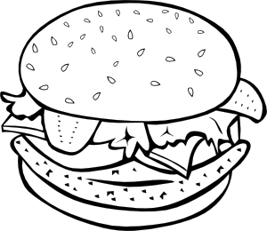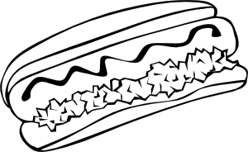
Vocabulary Sheet – Fast Food Culture
Word (parts of speech) | Meaning
Dietician (n) | a person who is an expert in nutrition or dietetics
Fast-food addict (n) | a person who is addicted to fast-food
Americanization (n) | assimilate to the customs and institutions of the U.S.
Delicacies (n) | something delightful or pleasing, esp. a choice food considered with regard to its rarity, costliness
Sedentary (adj) | characterized by or requiring a sitting posture
Coronary (adj) | of or pertaining to the human heart, with respect to health
Superficial (adj) | shallow; not profound or thorough
Standardize (v) | to bring to or make of an established standard size, weight, quality, strength
Unpalatable (adj) | not palatable; unpleasant to the taste
Franchise (n) | the right or license granted by a company to an individual or group to market its products or services in a specific territory
Variant (adj) | tending to change or alter; exhibiting variety or diversity
Proliferate (v) | to increase in number or spread rapidly and often excessively
prominent (adj) | standing out so as to be seen easily; conspicuous; particularly noticeable
Prevalent (n) | widespread; of wide extent or occurrence; in general use or acceptance
Ubiquity (n) | the state or capacity of being everywhere, esp. at the same time
Detrimental (adj) | causing detriment; damaging; harmful
Umpteen (adj) | innumerable; many
Flavor-enhancing (adj) | enhancing the flavor of food
Paramount (adj) | chief in importance or impact; supreme; preeminent
Consumer-friendliness (n) | products of non-harmful elements to consumers

