Bringing Hong Kong Movie Industry to a New Era
Rachel Chan (3)
Ruby Yuen (29)
F.6A

Introduction
From the 1980s to early 1990s, the Hong Kong movie industry was at its peak. (see Fig.1). However, in recent years, the popularity of locally produced movies has been steadily declining. More and more people prefer Hollywood/foreign movies.
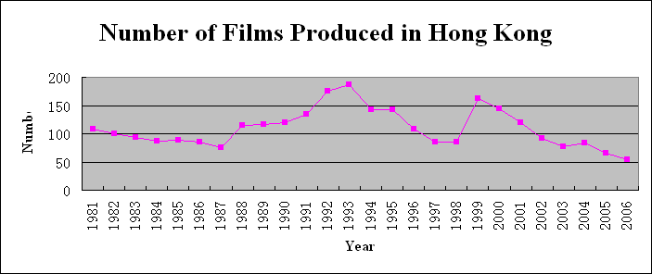
Fig. 1 Data from Hong Kong Film Archive
Dr. Sobel K.L. Chan, a senior lecturer of the Academy of Film, Hong Kong Baptist University was interviewed. He described the past and present situation in depth and competently suggested ways to enhance the production of movies. He also recommended ways to attract more talents.

Our report will first find out the recent trend of local movies. Then we will focus on the reasons and the feasible resolution to this crisis.

Current Situation

Hong Kong’s once thriving film-making industry is withering away. Both the number of production and box office earnings has gone downhill since late 1990s. At the peak of the industry, there were nearly 200 movies produced locally. In the past ten years, the number decreased, there were less than 60 movies produced per year in mid 2000s only.
At the same time, local audience prefer Hollywood movies to Hong Kong movies. This resulted in a drastic decline of box office earnings. Hong Kong movies have also lost their dominance in markets in South Korea, Thailand, Taiwan and Malaysia.
Talents are being distracted by the continuously declining situation and many of them have gone to Hollywood for better prospects.
Hence, the local movie industry is facing constraints in both production and market, it is a must for them to find suitable measures to aggrandize the circumstance.

Causes of the declining trend
1. Change in Quality
In the golden era of Hong Kong movies, many famous directors and producers for example Ann Hui, known as the “Hong Kong New Wave” were working hard in the local film-making industry. According to our interviewee Dr. Chan, the special feature of locally produced movies at the peak was the wide range of film genre and creativity. Audience were then attracted. The complete “star system” also created idols and superstars like Jackie Chan and Tony Leung who attracted many fans and audience. With both talented actors and producers, Hong Kong movies were of high quality and quantity.
However, Dr. Chan commented that overproduction led to decrease in quality. Among the enormous amount of production, many of them were sequels to successful movies rather than innovative films. Audience soon found them boring and dull. Moreover, a lot of local movie makers went to Hollywood for further development (see Fig. 2). Actors like Jackie Chan and Jet Li aimed at the international market instead of the local one. The Hong Kong movie market was then dominated by low quality comedies or violent films. In fact, the decline of the industry was not surprising at all.
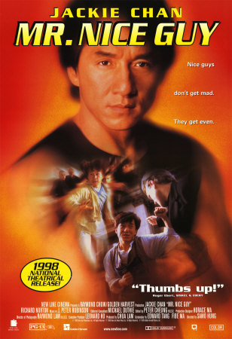 Fig. 2 Hollywood starred with Jackie Chan

2. Increasing Market Share of Foreign Movies
While the local movie industry was going downhill, audience soon focused on Hollywood movies. Other Asian movies were booming too. Foreign movies often have clearer and more specific themes and concepts than Hong Kong movies. Many of them have their own characteristic too. For example, Korean tragedies and Japanese romance are very popular. Between 1992 and 1996, the market share of American films in Hong Kong increased from 20% to 46%, in the same period. Box office earnings for Hong Kong movies declined by 50%. In the keen competition, the increased market share of foreign movies seriously affected the box office income of local movies.

3. Lack of talents
As mentioned in section 1, Changes in Quality, there were once a lot of local talents who were devoting themselves to movies. Later on they chose to explore the foreign market and many of them went to Hollywood. It means the industry is facing a shortage of creative and well-trained movie personnel and it is a must to attract more new comers to work in movie production. However, the movie industry is facing two major constraints. According to Dr. Chan, the first constraint is the nature of the industry. Film making is project oriented. In other words, there is no fixed income. Compared to other ordinary jobs, there is less welfare like medical or MPF benefit. Young people therefore are not willing to enter this industry. Secondly, film making is not as common as in foreign countries. Appreciation and production of movies is not included in education. We do not have much chance to learn about movie production, so young people lack knowledge and interest in movies. The lack of talents adversely affects the quality of locally produced films and thus worsens the future development of the industry

4. Piracy
Despite its development, the internet brings more harm than benefits to the local movie industry. Illegal downloading like Bit Torrent (also known as BT), and video sharing websites like Youtube provide alternative movie viewing methods. Moreover, the local and mainland pirated VCDs and DVDs provide audience with cheap movies. They started to show up in large numbers since 1995. They actually provide a wider range of films free or charge or at a very low price. In fact, they have robbed the Hong Kong film industry of 40% of its business. Some theatres or even VCDs/DVDs shop were forced to close down as well. The negative impact on the local box office earnings of course, directly causes huge loss to movie makers. Well-known movie star Jackie Chan once led a protest to denounce government plans to liberalize the import of laser disks. His worries are understandable as this is also one of the reasons that frightens talents and deteriorate the quality of local movies.

Recommendations

- Better education
In order to prevent the loss of talents, we recommend using education as a method. Education, for example the Professional Film Programme, high diploma, etc, is a more direct way to improve the quality, especially during practical training. Students can learn the skills from different departments, like lighting, art director, producer, sound making. If Hong Kong can have such adequate education system, this can attract more foreign investors and talents will have a larger chance to stay and develop their future.

- Better production mode and system
So as to improve the quality of local movies, we recommend the government to set up a better system for the movie industry. As the capital and budget provided for the film maker are too low, the range of production is stipulated, hence low quality is the result. A better system like providing more budget, better production mode, stable salary, etc, can protect the welfare of film maker, and they will have a higher incentive to work and produce good movies.

- Explore new market
As there is an increase in the market share of other Asian or foreign movies, Hong Kong should open new market so as to maintain our competitiveness. Our interviewee, Dr. Chan suggested they can explore the markets in South-east Asia and Europe, as there are less film investments. Thus there is less competition and it is easier to attract more investors. Therefore we can create a virtuous cycle for the movie industry.

In addition, the Hong Kong Government can help Hong Kong film industry to expand into the regional and global markets by requiring the Hong Kong Trade Development Council and the government's overseas offices to promote Hong Kong movies and generate overseas market reports, with the Hong Kong Film Development Council (HKFDC) serving as the driving force. Hence it would be much easier for the film maker to open new markets.

- More support from Film Development Council and setting up a Union for film industry

To attract more youngsters to work in the movie industry, we suggest the Film Development Council to provide more support. We think they can provide more grants and loans for them which can subsidize more and reduce their production cost. This can encourage youngsters to join this industry. Also this council can promote or hold an international festival, which can provide a chance to let the foreign film industries know more about Hong Kong movies. Besides this, we suggest the public to set up a Union for film industry, as one of the reasons for the declining trend in movie industry is that the present wage rate and welfare are undesirable. If there is the presence of the Union, we can ensure a healthy system for salary. Hence it would be fair to the workers and boost the development of Hong Kong movies.


- Hong Kong government should establish policy
Piracy is a threat to the producers to continue their business. For this, Dr. Chan recommends the Hong Kong government to establish a policy to repel piracy. She can increase the penalties for the illegal copying of movies, and setting up teams to fight off piracy. Also, she can ask schools to promote the importance of intellectual property rights and expand the channels for monitoring illegal Internet activities, so that we can enable local youngsters to directly participate in fighting piracy and allow them to cultivate the sense of respecting others' property rights at a young age.
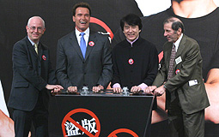

Conclusion
To sum up, the local film making industry is declining due to many factors. Firstly, the quality of local movies is deteriorating. Secondly, there is also increased market share of foreign movies and rampant piracy which worsen the box office earnings. Thirdly, the lack of talents is also unfavourable for the development of films in Hong Kong.
In order to boost the development of Hong Kong movies, we recommend providing better education to enrich the knowledge and skills of youngsters. Second, it is important to improve the production mode and system to raise the incentives of film makers. Third, there is also the need to encourage the film maker to explore new markets to maintain competitiveness. Fourth, the government should provide more support from Film Development Council and set up a Union for film industry.
Fifth, we recommend the Hong Kong government establish policies to fight off piracy. We hope these measures can help to attract more youngsters and talents to take part in the movie industry, and help Hong Kong to reach another “Golden Period".

Reference
- Hong Kong Film Development Council
- Academy of Films, Hong Kong Baptist University
- Public Policy Digest, University Grants Committee
- Sing Tao Daily
- Journalism and Media Studues Centre (Online Jounalism): www.jmsc.hku.hk

