Introduction

Our investigation intended to find out the seriousness of youth drug abuse, investigate the cause and impact of drug abuse as well as evaluate the remedial actions taken in utterly curbing the problem.

The malaise of drug abuse in Hong Kong is getting increasingly thorny. It is, woefully, reported that the issue of youth drug abuse is becoming more and more serious here in Hong Kong. Over the past few weeks, several youth drug abuse cases have been reported, including three students aged between 14 to 15 were found unconscious in the Tin Shui Wai Park, two 15-year-old girls were found in a daze at the Golden Beach, and four students from Rosaryhill School admitted that they had been abusing drugs in school. These youngsters are all suspects of psychotropic drug abusers. Cogent diagnosis and thorough solution must be carried out to harness abuses of psychotropic drugs. This report will provide a thorough analysis on youth drug abuse.

Ms. Joey Lam, a social worker of the Society for Aid and Rehabilitation of Drug Abuser was interviewed. She has sophisticated experiences in dealing with the problem of drug abuse. This report will further detail the background information of drug abuse and suggest ways to harness the current situation.

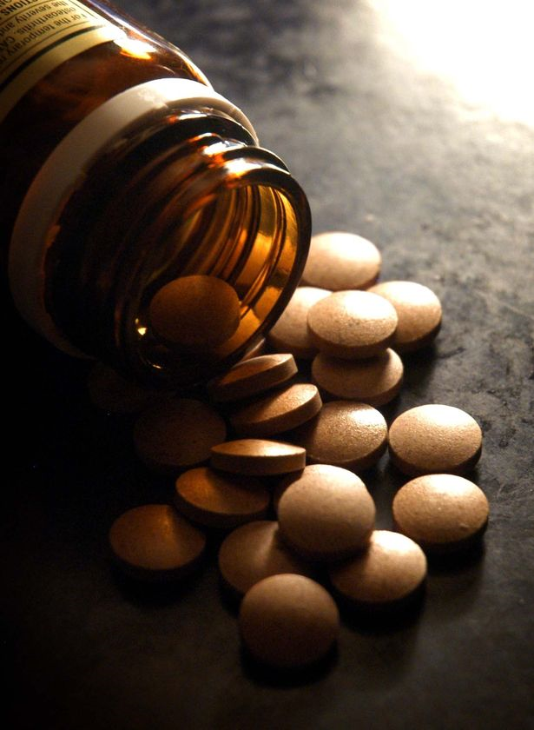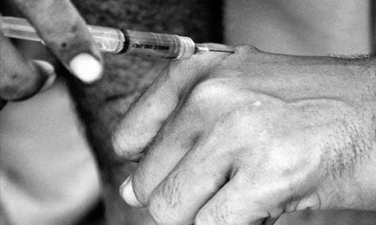

Statistic
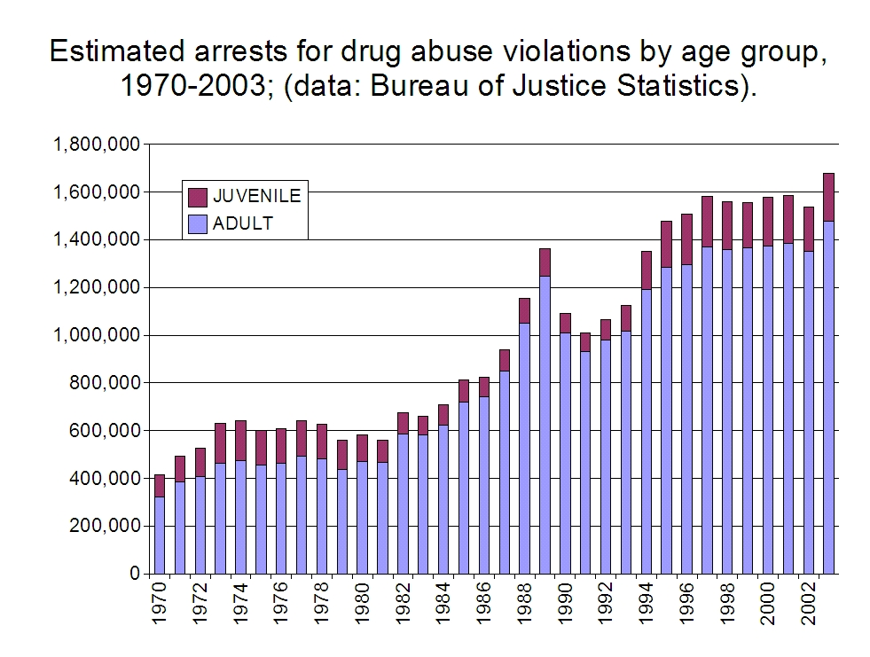
According to the Bureau of Justice Statistics, the number of juvenile drug abusers is soaring apparently between 1970 and 2002. This proves that the issue of youth drug abuse is becoming more and more serious here in Hong Kong.

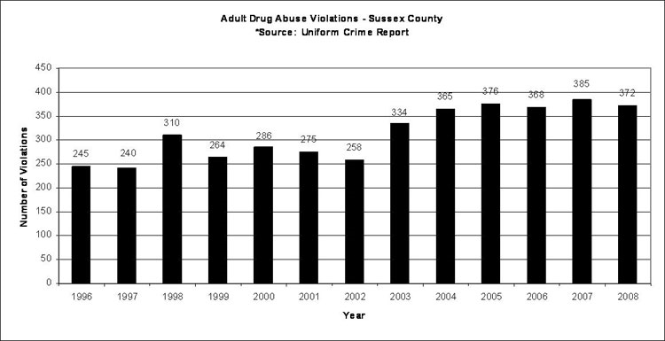

According to the Uniform Crime Report, number of violation increase from 245 in 1996 to 372 in 2008.

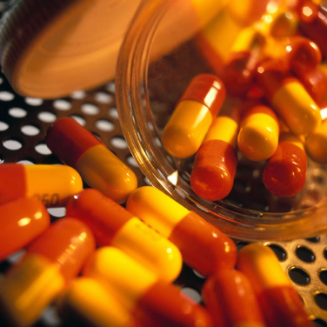

What causes drug abuse and addiction?
Genetic/Inherited
We are all a product of our parents. If your parents have addiction struggles, chances are you are more susceptible to addiction. That’s why drug abuse is more common in some families than in others. If your parents smoke, chances are good you will smoke. If your parents used alcohol, you’ll probably follow and use that drug in much the same way. If your father was an alcoholic, you have a predisposition to abusing that drug.
Peer Pressure/Social
We are all wired to have relationships, and sometimes those relationships cause us to give in to something we otherwise would avoid in order to maintain the relationship. Peer pressure is huge and nowhere is this greater than during our teenage years. Kids want to be cool. “It begins as a social action, to take drugs to be a part of the group, to be accepted.” Ms Lam said. It’s not just teenagers, as peer pressure takes so many different forms. Ms. Lam believed that there is social etiquette, for example, to take a drink during a party. “I’m a social drinker.” How many times have you heard that? Some people actually believe that drug abuse causes you to be accepted and part of the 'popular' group.
Easy Access
If you want to get drugs, you won’t have to look far because they are everywhere. High school students can tell you this. Drug abuse causes people to sell drugs to the most vulnerable population, children. It’s not just the stereotypical poor sections of the inner city that serve as the hotbed for drugs. Ms. Lam mentions that drugs are found in suburban shopping malls, rural schools, well-to-do private school, on the job in factories, offices and remote job sites. The easy access of drugs explains why the number of drug abuser increase sharply.
Psychological disorders –
We want to feel good physically and emotionally. Sometimes drugs are the substitution for a healthy life experience. The person may be pain and he may want to numb the pain. The drug numbs the pain and for a moment they don’t feel as poorly. The person needs to escape the pain of the life experience, and for a short while, the drug takes them away and they feel “better.”
Anxiety
Sometimes people need some help in coping with life. Everyday life becomes a struggle and simple things become too much to handle. “Drugs are gradually regarded as a mean to escape from pressure and reality” Ms. Lam said. In the case of addiction, we are not talking about the use of medication, under the care and observation of a doctor. People who have been clinically diagnosed with anxiety can lead a very good life. We’re talking here about people who just need to escape. Their choice of drugs facilitates that escape.
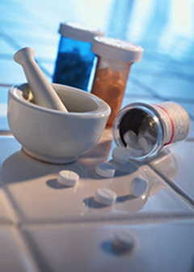
What is the impact of drug abuse?

Relationship

Drugs may lead to problems in different aspects, such as interpersonal relationships, activities of daily livings, etc. Drugs make a person act in an unreasonable way in normal life, and because of this, relationships between family and friends may be worsened. Drugs only bring negative impact to the users. People usually think that drugs can help a person to forget worries and problems in daily life, and so people start to try drugs when they face many difficulties. However, addiction can make the person give up all things in order to continue taking drugs. Arguments may then result, and this will totally worsen the relationships with family and friends. Besides these, people addicted to drugs will try to use all the money to buy drugs in order to minimize the pain derived from addiction. The waste of money will easily lead to disagreement and so relationships will be worsened.

Health

Health is the most important thing for a person. However, drug abusers may suffer from many difficulties and certain potential health problems such as lung disease, cancer, mental disorders. Serious cases may even lead to death. Drugs will ruin one’s mind, and the person who abuses drugs will not only suffer from certain health problems, but also a long-term influence on his psyche.

Future

It is difficult for drug abusers to obtain productive employment. As they may suffer from certain health problems and psychological impact, they may not be as competitive as those people who are healthy and with high productivity.

Crime

Crime and drugs are inter-related. Firstly, illicit production, manufacture, distribution or possession of drugs may constitute a crime; drugs may be closely linked to other major problems, such as the illegal use of guns, various forms of violence and terrorism. People who sell drugs are usually people involved in crimes. When a person starts to abuse drugs, they come in contact with such people and some teenagers cannot distinguish what is right or wrong and so it is much easier for teenagers to be involved in crime. Besides these, drug abuse is a waste of money. Whenever teenagers who are addicted to drugs are without sufficient money to buy drugs, they get involved in crime in order to gain money.
What is the solution to such problems?

Education

The government should provide some anti-drug programmes which can educate the teenagers in Hong Kong to know more about the negative impact and the seriousness of drug abuse. In the long run, education is the most effective way to change people’s mindset. There are several ways to promote the positive information such as advertisements, school programs, exhibitions, etc.

Parents

Parents should care more about their children and try to comfort them whenever there is something wrong or different with the children. Most of the teenagers try drugs because of lack of parents’ guidance. Parents should not only blame the children but also support them. Whenever their children are found to be drug abusers, they should try to talk to them, give them unlimited support and seek help from social workers and some professionals.

Government
The government should implement some policies that can tackle the problems of teenage drug abusers. The government should adopt the drug-testing scheme in different schools to stop the increasing number of teenage drug abusers and also give a clear guideline for schools to follow. Apart from that, the government should also increase the number of social workers of different organizations in all districts. The government should also form a team of people to deal with such problems. Furthermore, since Hong Kong is in lack of some rehabilitation centres and youth drug treatment, the government should also increase the number of rehabilitation centres and provide more services or treatment to help the teenage drug abusers.

Conclusion

Drug abuse has become very serious among the teenage population. It is easier to get drugs nowadays in different ways, like peers and families. Teenagers can easily access to drugs if their parents are also drug abusers. Suffering from peer pressure, teenagers may have the though of being isolated by their friends if they refuse the request from their friends in asking them to try drugs. These two are also the main factors in leading to the seriousness of teenage drug abusers. Also, teenagers may also try drugs out of their curiosity and the wrong attitude towards the misuse of drugs as they may think that taking drugs can help them to hide from their problem.

There are many impacts of taking drugs and most of them are negative. Drug abusers will suffer from certain health problems and the most serious case may lead to death. It will also affect one’s inter-personal relationships and social life. Besides these, the future of drug abusers will be ruined and it would be hard to find a well treatment in the job market. Most of the employers will not want people who have ever tried drugs.

Apart from that, the government, parents should bear the responsibilities of this problem. Teenagers have less life experience and so they will try to follow what people around them are doing. Society should not only blame on the teenagers. It is better to take action to solve the increasing trend of teenage drug abusers if it is not a minor problem in society. To tackle this problem immediately, the government and parents should cooperate together to create a no-drugs environment and adopt anti-drug programmes for teenagers and strengthen the manpower of the social work in the district. The adoption of Mandatory Drug Test in the past few months is not very effective in tackling this problem. It can only show how serious the problem is. Although students may be afraid to let their parents know that they are taking drugs and the drug test can also help to know that a teen is taking drugs so as to stop them from drug abusing immediately

The best way to solve this problem is education with bring out harsh penalties. Education can change one’s mindset and the government should provide more talks or exhibitions that can show the consequences and negative effect of drug abuse to the teenagers in order to let them know it is not worthy to try drugs for even once only. Also, with harsher penalties, teenagers may be frightened by that and not dare to try drug.

Vocabulary List

Vocabulary | Meaning | Sentences
Illicit | Not legally permitted or authorized; unlicensed; unlawful. | Drug abuse is illicit.
Prescription | The act of establishing official rules, laws, or directions | The surgeon wrote a prescription for a pain killer and physical therapy.
Self-resilience | The power or ability to return to the original form, position, etc., after being bent, compressed, or stretched. | An alloy is combined with strength and resilience.
Impair | To make or cause to become worse | Previous research suggested that even low levels of cerebral dysfunction can impair a person's quality of life and make him unfit to drive.
Hallucination | A sensory experience of something that does not exist outside the mind, caused by various physical and mental disorders, or by reaction to certain toxic substances, and usually manifested as visual or auditory images. | Drug addicts often hallucinate.
Apathy | Lack of interest in or concern for things that others find moving or exciting. | She heard the story with apathy.
Paranoia | A mental disorder characterized by systematized delusions and the projection of personal conflicts, which are ascribed to the supposed hostility of others. | He suffers from paranoia after taking drugs.
Delusion | An act or instance of deluding. | This man suffers from the delusion that he is a monkey.
Notorious | Widely and unfavorably known: a notorious gambler. | The town is notorious for its casinos.
Narcotic | Any of a class of substances that blunt the senses, as opium, morphine, belladonna, and alcohol, that in large quantities produce euphoria, stupor, or coma, that when used constantly can cause habituation or addiction | He was sent to prison on a narcotics charge.
Sluggish | Indisposed to action or exertion; lacking in energy; lazy; indolent | I feel very sluggish.
Detrimental | Causing detriment; damaging; harmful. | The measures had a detrimental effect.
Soiree | An evening party or social gathering, esp. one held for a particular purpose; a musical soiree. | He has to participate in the soiree tonight.
Semi-conscious | Partly conscious; not clear-headed | A semi-conscious patient is recovering from an anaesthetic.
Overdose | Too great an amount (of a drug ) taken at one time | He has taken a massive overdose of sleeping tablets since he was suffered from insomnia.
Tranquilizer | Medicine/drugs that can let people calm down | The doctor gave some tranquilizer to the patient as the patient was very emotional.
Stupor | Condition of being dazed or nearly unconscious caused by shock, drugs, alcohol, etc. | He was in a drunken stupor last night.
Appetite | Physical desire, especially for food or pleasure | When I was ill, I completely lost my appetite.
Precautions | Thing done in advance to avoid danger; prevent problems, etc. | Please take an umbrella just as a precaution.
Symptoms | Change in the body that indicates an illness | The rash is a symptom of measles

