Report On Animal Cruelty in Hong Kong

Introduction

Our investigation intended to find out how serious the question-animal cruelty-is in Hong Kong. At present, cruelty to animals is a problem in Hong Kong which needs immediate attention. Cruelty to animals is the infliction of suffering or harm upon animals, other than humans, for purposes other than self-defense. More narrowly, it can be harm for specific gain, such as killing animals for food or fur use. Diverging viewpoints are held throughout the world. We have investigated the attitude of Hong Kong citizens towards keeping animals as pets, whether they treat them as family or toys. Also, we have tried to find out whether pets should be allowed in housing estates and suggest ways to combat the problem of animal cruelty. The report further details the efficiency and effectiveness of animal protection policies carried out by the Hong Kong SAR.

Miss Cheung Yuen Man, an expert on animal cruelty, who is also a committee member of the Animal Earth was interviewed. She provided a lot of information about animal cruelty and shed light on local animal associations’ effort in solving this problem and arousing public’s awareness on animal abuse.

Current Situation
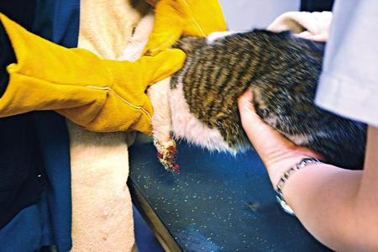
The news of animal cruelty in Hong Kong has been increasing recently and has aroused public concern; for example, there was a cat-slaughter in Choi Yuen Chun in ShangShui.
We found that most of the reasons for animal cruelty is stress. With the increasing in stress of Hong Kong people, the higher the rate of animal cruelty is being found to be higher in Hong Kong. The continuous growth in rate of animal cruelty shows that Hong Kong government has overlooked the education of how to treat animals. The problem will be more serious if the Hong Kong government continues to be blind to it.

Nonetheless, the number of animal being euthanized by the AFCD (i.e. Agriculture, Fisheries and Conservation Department) is decreasing in these few years which means that there are still benevolent people adopting the animals. It is a good sign for the issue on animals of Hong Kong. (Refer to the fig. below)

Our interviewee mentioned that the cases of animal cruelty happen in the housing estates are hardly discovered by others. People do not know what others are doing in their own flat, also evidences are hardly found. At the same time, since the Hong Kong government is not serious to the cases about animal cruelty, the penalty of the offenders are too light.
Eg. Only HKD$400 is paid for leading a dog died because of starving.
Findings

Attitude of Hong Kong citizens towards keeping animals as pets

- News about Animal Abuse
A pet is not just for Easter, SPCA warns
South China Morning Post, published a news about the amid fear of increasing abandonment during Easter on the 11th April, 2009. They cautioned that for those planning to buy pets to give as gifts in the Easter holiday spirit should think twice .
The trend to buy animals impulsively as festive gifts has been easing in the past three to four years but they caution people against impulsively buying - then abandoning their pets.
Hong Kong people usually buy the pets on an impulse, ignoring the responsibilities of keeping them. They buy pets for gifts but after a while, they cannot take good care of them and they abandon them at last.

- Policies made by the Hong Kong government

Name: Penalty for cruelty to animals
Duration : Started from 15th December, 2006
Content : Anyone who causes any unnecessary suffering or, being the owner, permits any unnecessary suffering to be so caused to any animal, for example, beats, kicks, ill-treats.
Comments: The penalty of this law is insufficient to reflect the seriousness of this offense because the sentence is usually social service order. The process seems to be meaningless and has no deterrent effect.

- Successful measures carried out by the overseas governments
- United Kingdom
In the United Kingdom, cruelty to animals is a criminal offense for which one may be jailed for up to 51 weeks and may be fined up to £20,000.On August 18, 1911, the House of Commons introduced the Protection of Animals Act 1911 (c.27) following lobbying by the Royal Society for the Prevention of Cruelty to Animals (RSPCA). The maximum punishment was 6 months of "hard labour" with a fine of 25 pounds

- United States
The primary federal law relating to animal care and conditions in the US is the Animal Welfare Act of 1966, amended in 1970, 1976, 1985, 1990, 2002 and 2007. It is the only Federal law in the United States that regulates the treatment of animals in research, exhibition, transport, and by dealers. Other laws, policies, and guidelines may include additional species coverage or specifications for animal care and use, but all refer to the Animal Welfare Act as the minimum acceptable standard.
The AWA has been criticized by animal rights groups for excluding birds, rats and mice bred for research, as well as animals intended to be used for food or fiber; as well as all cold-blooded animals.
The Animal Legal Defense Fund releases an annual report ranking the animal protection laws of every state based on their relative strength and general comprehensiveness. In 2008's report, the top five states for their strong anti-cruelty laws were California, Illinois, Maine, Michigan, and Oregon. The five states with the weakest animal cruelty laws were Arkansas, Idaho, Kentucky, Mississippi, and North Dakota.
In 2004, a Florida legislator proposed a ban on "cruelty to bovines," stating: "A person who, for the purpose of practice, entertainment, or sport, intentionally fells, trips, or otherwise causes a cow to fall or lose its balance by means of roping, lassoing, dragging, or otherwise touching the tail of the cow commits a misdemeanor of the first degree." The proposal did not become law.
Recommendations
A. Better Civic Education
Education is a long-term solution to help teacher the citizens how to treat animals well. Education teaches the public and the youngsters about the appropriate attitude in keeping pets at home and treating the stray dogs and cats on the street. The AFCD can also promote the adoption of pets so as to let the younger generation have more understanding about the animals and nature.

B. Better Understanding about Animals
The volunteer groups may cooperate with the AFCD to hold some exhibitions about animals and invite schools to have visits. This may increase youngsters’ understanding about animals. With better cooperation between government departments, they can be more effective in carrying out activities or campaigns for the public.

C. Legislation
By legislation, the situation can be improved in the short term. If citizens would be penalized much harsher than now, they will change their behaviours immediately as to avoid being caught and punished. Therefore, it is effective to adopt a harsher policy towards the penalty of abusing animals.

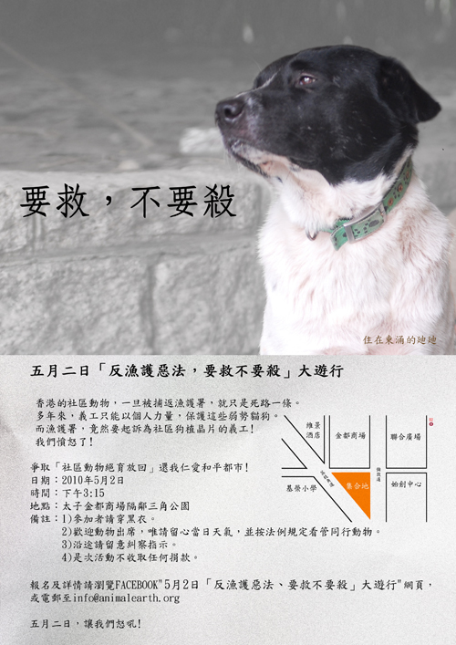
D. Join the Activities
Citizens may pay more attention to the activities held by the volunteer groups. The volunteer groups often hold activities to reflect their dissatisfactions towards the government. For example, there will be a parade held on 2nd May,2010. The aim of this parade is to oppose the penalty of a volunteer who had been accused for leaving the dog alone during a walk in a park.

E. People should not be allowed to keep pets
Our interviewee mentioned that the mentality of HK people is not suitable for keeping dogs. They think the barking of dogs will disturb others. Wherever there are pets, people will think they are annoying and dirty. Since Hong Kong citizens are not ready to face the responsibility of keeping pets. Therefore, we don’t think Hong Kong citizens are ready to keep pets. But we believe that we can change this situation by education and promotion.

F. Help the animals
If we saw any animal being hurt by others, we should not close our eyes to it; we should immediately stop the offender and send the animal to the organizations such as SPCA: they have shelter for the animals being hurt. But there are also organizations, such as Animal Earth, would help to promote sense of protecting animals.
Conclusion
It is found that the Hong Kong government is actually not serious about the problem of animal cruelty.
Firstly, the government and AFCD is not actively participating in promoting the idea of not to abuse animals. The education of this idea is definitely insufficient among the schools and for the public.
Secondly, the pressure on the government for solving this problem is not enough. As a result, the government does not face this problem seriously. When there are someone reports to the AFCD that someone seems to be abusing his or her pet, they just go and ask casually and close the case.
Luckily, there are many volunteer groups (e.g. Animal Earth)which monitor government’s attitude. This heaves the importance of animals in society.
At last, we hope the Hong Kong government can take the policies of other countries which mentioned above as reference, so as to improve the current policies and situation of animal cruelty in Hong Kong.

Reference
# Animal Earth
# Agriculture, Fisheries and Conservation Department
# hkanimalpolicy.blogspot.com
# SPCA
# Yahoo News

No. |  | Vocabulary |  | Meaning |  | Sentence
1 | Stray |  | They got lost when they strayed too far from the footpath. |  | A stray dog or cat has wandered away from its owner's home
2 | Detain |  | When people such as the police detain someone, they keep them in a place under their control. |  | A suspect has been detained by the police for further questioning.
3 | Neutered |  | When an animal is neutered, its reproductive organs are removed so that it cannot create babies. |  | Has your dog been neutered?
4 | Lethal |  | A substance that is lethal can kill people or animals. |  | In the car the police found guns, knives and other lethal weapons.
5 | Abandon |  | If you say that someone does something with abandon, you mean that they behave in a wild, uncontrolled way and do not think or care about how they should behave. |  | As a baby he'd been abandoned by his mother.
6 | Drained |  | Very tired and without energy |  | You look completely drained - why don't you go to bed?
7 | Campaigning |  | A campaign is a planned set of activities that people carry out over a period of time in order to achieve something such as social or political change. |  | The protests were part of their campaign against the proposed building development in the area.
8 | Apprehensive |  | Someone who is apprehensive is afraid that something bad may happen. |  | I'm a bit apprehensive about tomorrow's meeting.
9 | Maimed |  | To maim someone means to injure them so badly that part of their body is permanently damaged. |  | Many children have been maimed for life by these bombs.
10 | Delicacy |  | Delicacy is the quality of being easy to break or harm, and refers especially to people or things that are attractive or graceful. |  | In some parts of the world, sheep's eyes are considered a great delicacy.
11 | Carnivorous |  | Carnivorous animals eat meat. |  | Snakes and dogs are carnivorous.
12 | Domesticated |  | To train or adapt (an animal or plant) to live in a human environment and be of use to humans. |  | The only mystery about the cat is why it ever decided to become a domesticated animal.
13 | Vulnerable |  | Someone who is vulnerable is weak and without protection, with the result that they are easily hurt physically or emotionally. |  | Old people are particularly vulnerable members of our society.
14 | Predators |  | A predator is an animal that kills and eats other animals. |  | People sometimes refer to predatory people or organizations as predators.
15 | Exotic |  | Something that is exotic is unusual and interesting, usually because it comes from or is related to a distant country. |  | She flits from one exotic location to another.
16 | Dehydrate |  | If you dehydrate or if something dehydrates you, you lose too much water from your body so that you feel weak or ill. |  | A child who's got diarrhea and is suffering from dehydration.
17 | Adoption |  | The decision to start using something such as an idea, a plan or a name. |  | Once you have adopted a pet, you should be responsible to it.
18 | Floodgates |  | If events open the floodgates to something, they make it possible for that thing to happen much more often or much more seriously than before. |  | A decision against the cigarette companies could open the floodgates to many more lawsuits.
19 | Prosecution |  | An action of charging someone with a crime and putting them on trial. |  | Yesterday the head of government called for the prosecution of those responsible for the deaths.
20 | Inhumane |  | If you describe something as inhumane, you mean that it is extremely cruel. |  | He was kept under inhumane conditions.

