1. Introduction
A broad definition of child abuse implies purposeful and serious injury inflicted upon a child by a caregiver, both physically and psychologically. It can be recognized into four categories: neglect, physical abuse, sexual abuse and psychological abuse. Sometimes it can also be multi-abuse, which is a combination of them. It is not suitable to say which form of abuse is more serious because there are uneven levels of physical and psychological harms for each kind of abuse.
At present, cases about child abuse are observably increasing in Hong Kong. News reporting about mothers committed suicide with their kids shocked the society and people in Hong Kong can no longer pull the wool over their eyes to realize the seriousness of child abuse. The report is intended to analysis the reasons leading to the increasing trend of child abuse.

Mrs. Priscilla Lui, the Director of Against Child abuse was interviewed. The report further details the effectiveness of the child abuse laws implemented by the government in Hong Kong compared with other countries. It also suggests what kind of measures and improvement the government and organizations can help to arouse social concern on this issue and improve the situation.
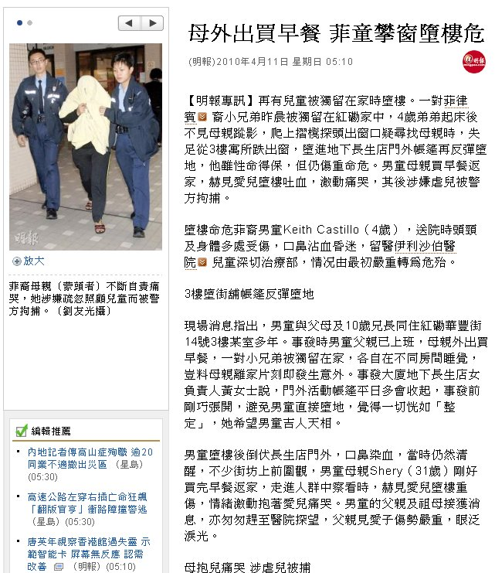

Fig.1 news about mothers committed suicide with their kids
2. Current situation

2.1 Contributing factors of child abuse

The contributing factors for child abuse can be summarized into the two categories, parental side and children side.
It is found out that parents or cares abused their children because they were treated in this way in their childhood, which their youth hood or adulthood had not been properly taken care or experience different forms of lack of supervision or maltreatment, such as abuse. Because of the reason that the parents or cares have been badly treated, or neglected, so they may not be aware that kind of action is wrong as they had been treated in this way. They may feel shamed about this so they may naturally do the same thing.
The second category of contributing factors would be the child factors. Innocent children may do things which they may not be aware that would provoke their parents. However, it is true that children in developmental stages may produce problems which parents may be difficult to handle. It this way, parents may not know how to overcome the problems of their children, and they may use violence in order to make their children to obey them.

2.2 What kind of abuse dominate in HK
Statistics on cases involving child abuse is captured by the Child Protection Registry (CPR) .The number of newly reported child abuse cases (from January to December 2009) is reported below:

Fig.2 Newly Reported Child Abuse Cases from January to December 2009
From the above figure, it shows that over 50% of the cases of child abuse are cases of physical abuse (503 cases out of 993 cases). Nearly 50% of the cases are cases of child neglect (102 cases out of 993 cases) or sexual abuse (331 cases out of 993 cases). It can show that these three abuses dominate in Hong Kong.
3. Findings
- Policy made by the Hong Kong government
Name: | Ill-treatment or neglect by those in charge of child or young person
Chapter: | 212
Section: | 27
Content: | If any person over the age of 16 years who has the custody, charge or care of any child or young person under that age willfully assaults, ill-treats, neglects, abandons or exposes such child or young person or causes or procures such child or young person to be assaulted, ill-treated, neglected, abandoned or exposed in a manner likely to cause such child or young person unnecessary suffering or injury to his health (including injury to or loss of sight, or hearing, or limb, or organ of the body, or any mental derangement) such person shall be guilty of an offence and shall be liable
Duration: | 3 years

Though the law specified the penalty of three years if any person mistreat or neglect the child or young person he or she is in charged of, it did not clearly specify the age of the guardian, this may lead to a situation that the guardian of the children or young person may be even below the age of 18.

B. Measures by local non-governmental organizations (NGOs)
There NGOs that provide various professional assistance and support the affected children and parents. These organizations play an important role to prevent child abuse by different measure.
Against Child Abuse Ltd.
- Hotline: the public is encouraged to call and report suspected cases of child abuse/neglect. After assessment on children in risky or abusive situations, professional assistance will be given to tackle.
- Casework: the cases are handled by social workers who investigate into them and take appropriate action such as counselling, home visit and collateral interview.
- Group Work: group work services range from educational, therapeutic, and developmental to recreational and networking. Such groups provide the abused children, abusive parents and families the opportunity to explore communication patterns, develop strengths and potentials etc.
- Other Services: these services include drop-in consultations, publicity, talks and seminars, volunteer services, training programmes for social work students and volunteers. A lot of emphasis has been put on advocacy through the mass media and community projects.

End Child Sexual Abuse Foundation (ECSAF)
- “Hugline" & Counseling: Social workers are available to provide the public information related to child sexual abuse, to offer immediate ventilation of stress for callers, and to give referrals to four psychologists offering counseling services to victims, abusers and their families.
- Workshops :In order to raise the awareness of the general public on the importance of child protection against sexual abuse, ECSAF has workshops for parents and teachers
- Education Programs :The ECSAF Sex Education Programs are for local primary and secondary schools in Hong Kong, with a focus on developing proper attitudes towards sex and providing information and instruction on protection from sexual abuse.

C. Measures by Canadian government
In compare to an overseas government that we have chosen—Canada, there are several measures had been taken in preventing and handling the child abuse cases.
Laws
- the introduction of mandatory reporting laws
- the creation of child abuse registries
- changes to the Criminal Code and the Canada Evidence Act (see Reforming the law and enhancing its implementation);
- the extension of time limits for laying charges in child sexual abuse cases, and
- the establishment of child protection agencies run by First Nations.
Education
Education involves providing children with knowledge about their rights, and teaching them the skills to identify abuse, ask for help, and avoid being re-victimized.
Professional development and resources
The Department works with its partners to support specialized training for justice system and law enforcement personnel in order to build a coordinated multi-sectoral, multi-disciplinary response with other systems.
Support for program and service delivery
Through project funding the Department of Justice Canada supports pilot projects to develop, test and assess models, strategies and tools to improve the criminal justice system's response to child abuse.

4. Recommendations

The following are some of the suggestions of ways to improve the situation of child abuse in Hong Kong:
A. Monitoring and protecting children through school network and neighbourhood network
In order to strengthen the protection of children, government can minimize the cases of child abuse through the school network and neighbourhood network. The government can cooperate with the shop owners, housing estate management office and other organizations and beware of any cases of children who is home alone in any moment and give reports in order to minimize the probability of children having accidents.

B. Amendment on laws
The laws on protection on children are not enough and the government can specify the age of the guardian and children under what age should be take care and well-protected by responsible adults. Specifying the age of the guardian can prevent the situation of children taking care of children happened. The government can also make review on cases of child abuse, following the example of England. In this case, the government can show its determination on removing child abuse.

C. Set up Commission for children affairs
The government can set up commission for children abuse by taking referencing resources of other foreign countries (e.g. England). Special officers for child affairs can be appointed to ensure children’s right can be protected.

D. Arousing public attention on child abuse
The government can spread the message of importance of harmonious family to the public through TV advertisement and distributing leaflet. The government can arouse public attention in this way and more and more families will be aware of the importance of harmonious family. Furthermore, the government can include ways for the needed to seek help which they can be immediately helped.

5. Conclusion

With the significance increase in the numbers of child abuse cases in Hong Kong, it is noteworthy to both the government and the members of public. This report has thoroughly explored the seriousness of child abuse, including the factors contributed to it, the measures used by the local government and the non-governmental organization as well as prevention and solution of child abuse adopted in Canada against child abuse.
It is true that the Hong Kong government has put more and commendable efforts in preventing and handling the child abuse cases. However, as a matter of fact, to preclude the increasing statistics of child abuse cases, a high standard of cooperation among the government, the NGOs and the public are much needed.
To the government, promotions against child abuse need to be strong and comprehensive. With involving the public participation, the message of preventing child abuse and also developing a harmonious family need to be sent out in a effective whilst practical way. To the NGOs, they have to continue the strong bound with the government’s policies on the benefits of children, as well as to arouse public awareness on this issue. Provide professional and continual assistance to the disturbed parents and the affected children immediately. While to the public, we should be more sensitive to the current issue and show our concerns and enthusiasm to help our neighbours. As being a parent, seek help immediately if they come across difficulties in communicating with their children, vice versa. In such a way, the tragedy of child abuse can be reduced and prevented, and to create a harmonious family and society.

6. Reference
http://www.swd.gov.hk/vs/english/stat.html
http://www.legislation.gov.hk/blis_pdf.nsf/f0464bbe8e4b6a514825755c00352e36/f8dd9956a1ac9ee5482575ee004d53f7?OpenDocument

Vocabulary List
Vocabulary | Meaning
1.Child neglect | Failure to provide for the shelter, safety, supervision and nutritional needs for a child
2. abandonment | to leave a place, thing or person forever
3. Spousal abuse | abuse to the person they are married to
4. Foster care | Twenty-four-hour substitute care for children placed away from their parents or guardians
5. Drug abuser | An individual who uses illegal drugs or legal drugs in excess
6. Commercial sexual exploitation | allowing, permitting or encouraging a child to engage in prostitution
7. Sexual abuse | someone forces them to take part in sexual activity with them, often regularly over a period of time
8. Tolerance | Quality of allowing other people to say and do as they like, even if you do not agree or approve of it.
9. Emotional neglect | Fail to know the feelings of child
10. mistreating | If someone mistreats a person or an animal, they treat them badly, especially by making them suffer physically

- Child neglect is the most frequently reported form of child abuse.
- As a baby he'd been abandoned by his mother.
- Spousal abuse is a type of domestic violence.
- The boy who faced child abuse is having the Foster care.
- The father of the boy is discovered as a Drug abuser.
- The girl was being Commercial sexual exploited.
- Sexual abuse is a form of exploitation of child and is a form of illegal sexual activity.
- If a government or organization has a policy of zero tolerance of a particular type of behaviour or activity, they will not tolerate it at all.
- Emotional neglect is treated as a way of child abuse.
- She has been mistreated by men in the past.

Vocabulary | Meaning
11. Child abuse | Physical or emotional mistreatment of children.
12. Poverty | Condition of not able to afford basic human needs such as nutrition, health care, clothing and shelter.
13. Expulsion | the act of driving out or expelling.
14. Depression | feelings of sadness, helplessness, or hopelessness
15. Malnutrition | Insufficient, excessive or imbalanced consumption of nutrients.
16. Parental substance abuse | Overindulgence in and dependence of a drug or other chemical leading to effects that are detrimental to the parent's physical and mental health.
17. Sexual coercion | The making of unwanted and offensive sexual advances or of sexually offensive remarks or acts
18. Gambler | to play at any game of chance for money or other stakes.
19. Sexually molested | to assault sexually (= sexual harassment)
20. psychiatric report | report or document of mentally disorder case

11. The situation of child abuse is getting worse in Hong Kong and public awareness is needed.
12. Poverty has a profound influence on Hong Kong’s society, such as the wide wealth gap.
13. Child abuse leads to expulsion of happiness in the rest of the child’s life.
14. Depression of parents can lead to child abuse, like beating their child
15. Almost everyone is malnutrited in Africa because of insufficient resources, the corrupted government and poverty.
16. Parental substance abuse can lead to serious consequence, like blaming or even hurting children beyond reason.
17. Sexual coercion is not rare in child abuse cases and most of them are enclosed years after the initiation.
18. Gamblers are heavily addicted to gamble and seldom conscious about other matters.
19. Most women choose to tolerant when they are sexually molested.
20. The court may need a psychiatric report to judge a child abuse offender.

